In this assignment, you are required to configure **Azure AD Cloud Sync with Pass-Through Authentication (PTA)** instead of using ADFS, as demonstrated in class. Set up the configuration, ensuring proper certificate setup with the common name as sts.race.sc200.info, and perform hostname verification. Take clear screenshots of each step and document them in a Word file. After completing the configuration, include a short comparison between **PTA and ADFS**, explaining when each should be used.

**To configure Azure AD Cloud Sync with Pass-Through Authentication (PTA)**

1. **Create the Resource Group -onprem-rg and**
2. Create VNET with name **onprem-vnet**

CIDR 10.111.0.0/16

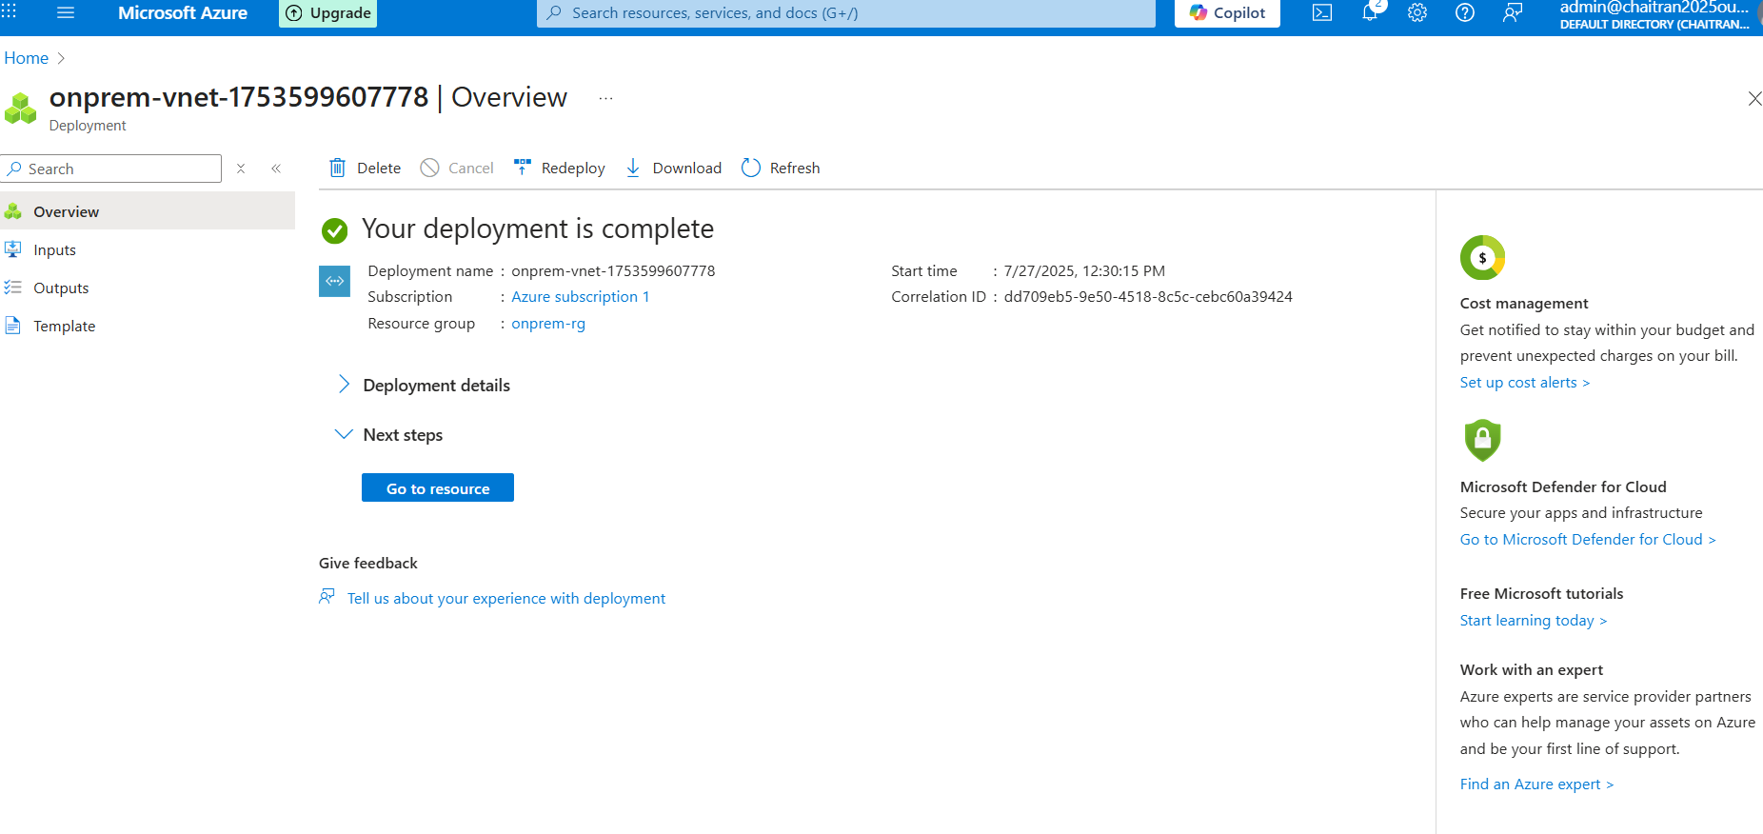

1. **Create the Virtual Machines**

**Named 🡪 dc-vm, disk type 🡪 Standard SSD**

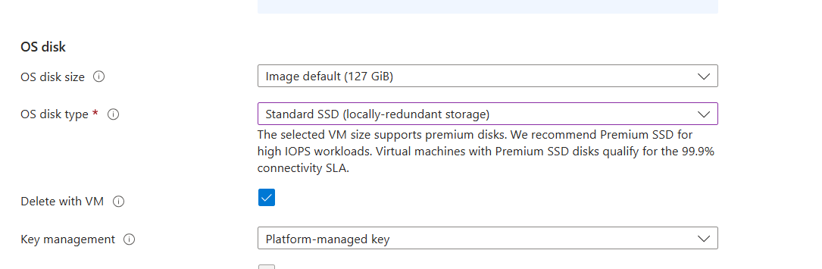

Select the onprem-vnet

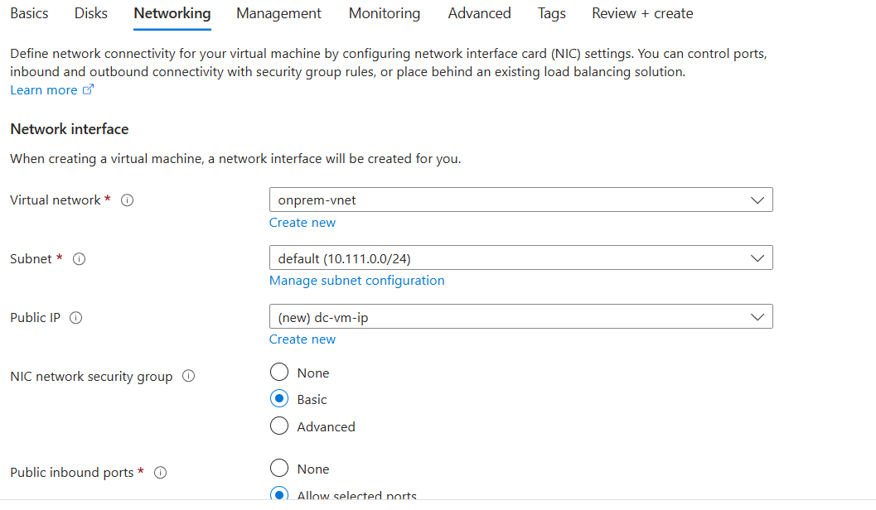

Disable Boot Diagnostics

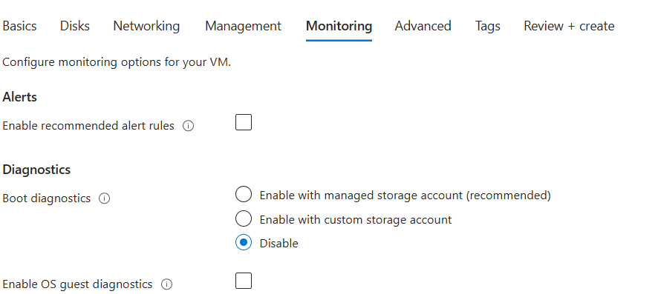

Review and create.

1. **Create** **second VM**

Named 🡪 **mem-vm**

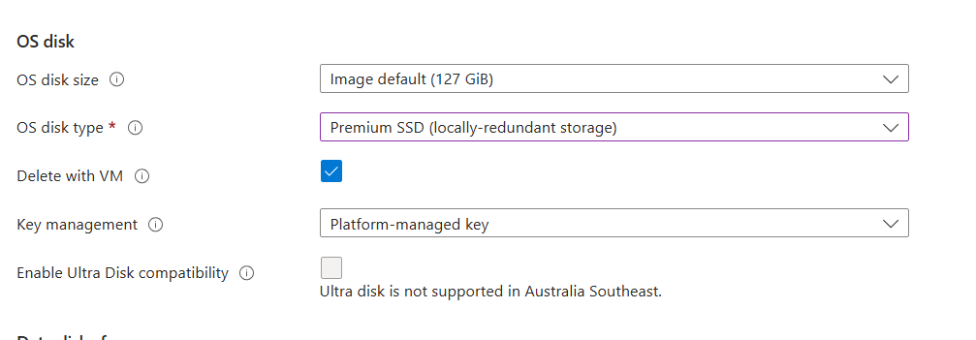

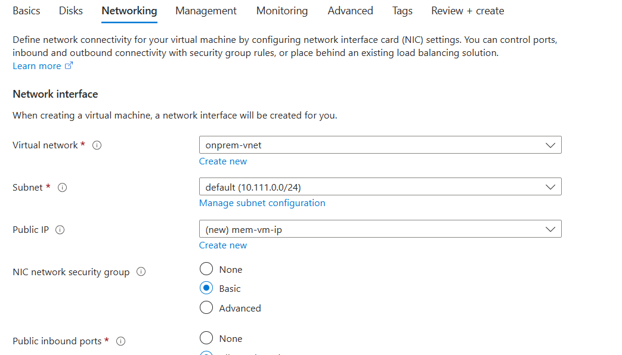

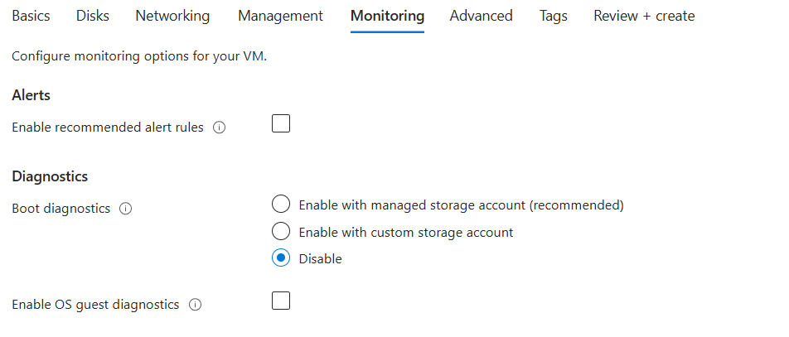

Review and Create.

Both the VM’s are created as shown in below screenshot

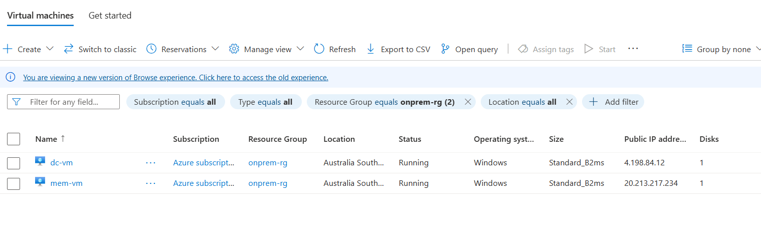

1. **Enable Inbound ports destination * to both dc-vm and mem-vm**

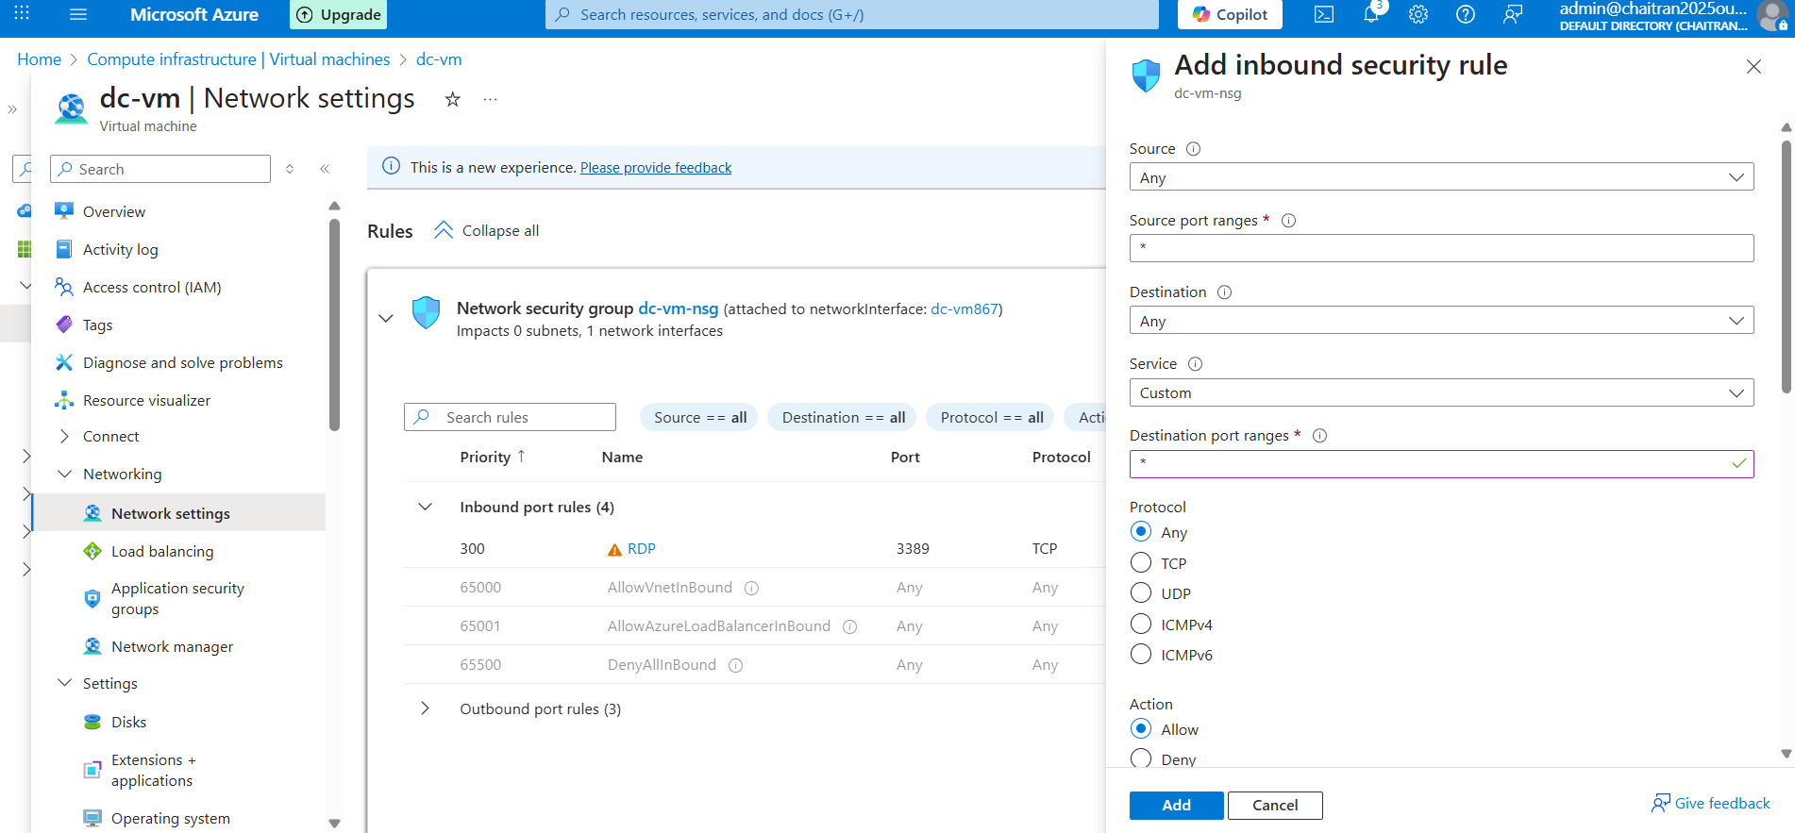

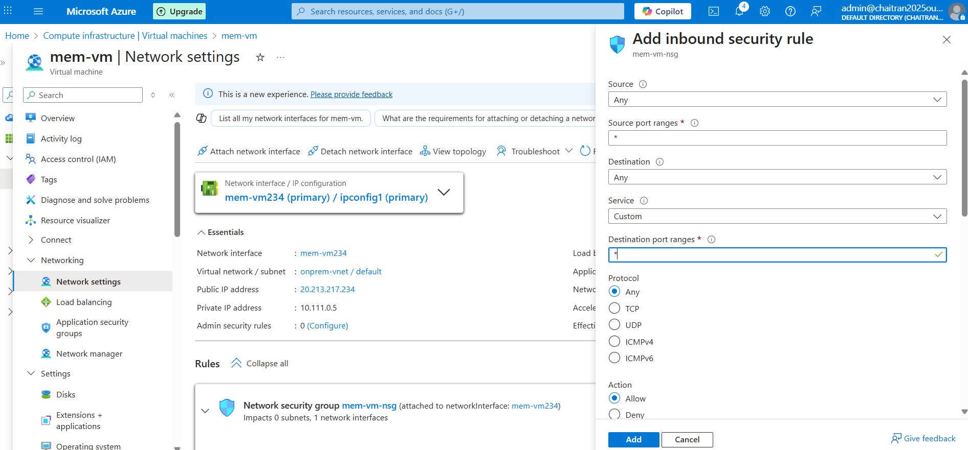

1. **Access the VM using Public ip via RDP**

Public IP of DC-VM

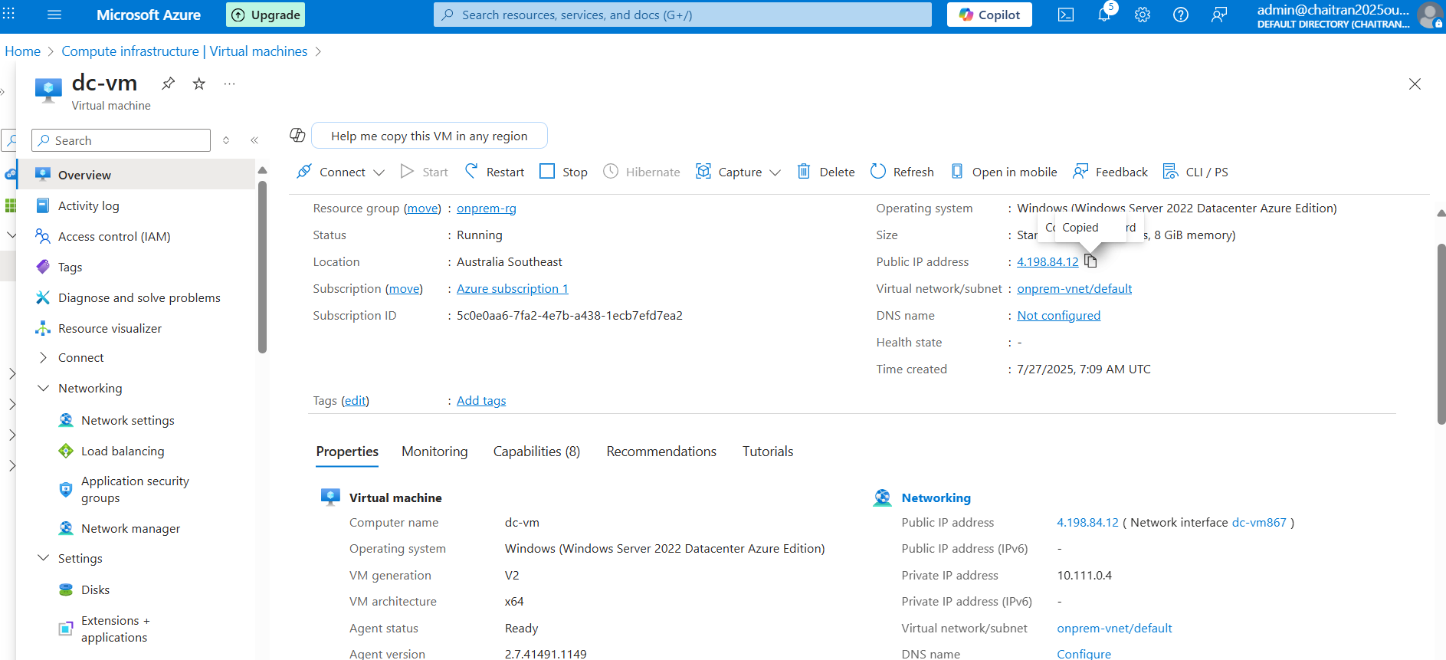

Add roles

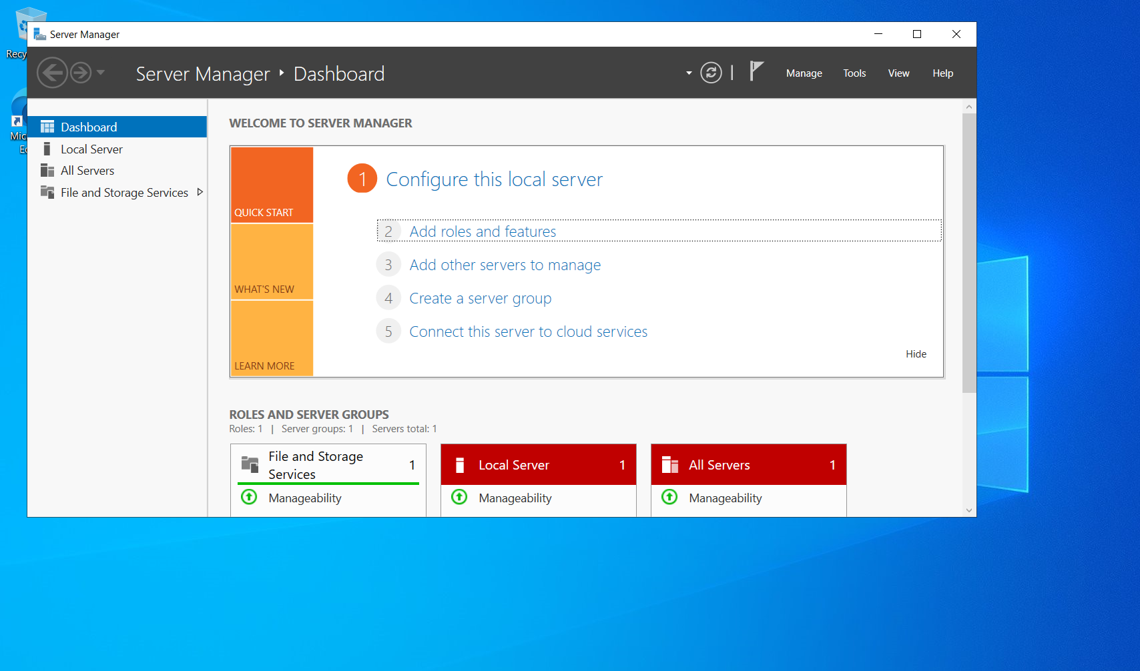

Select Active directory – ADDS

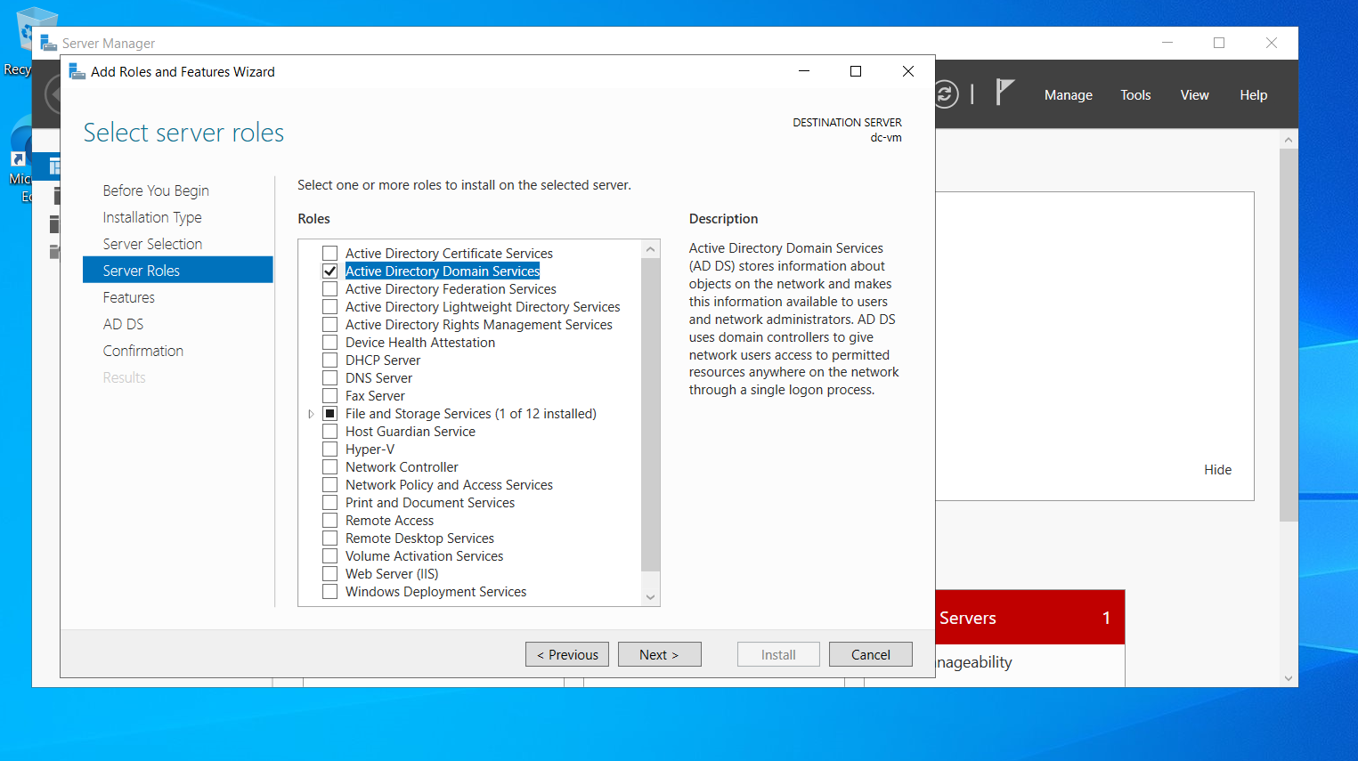

Install

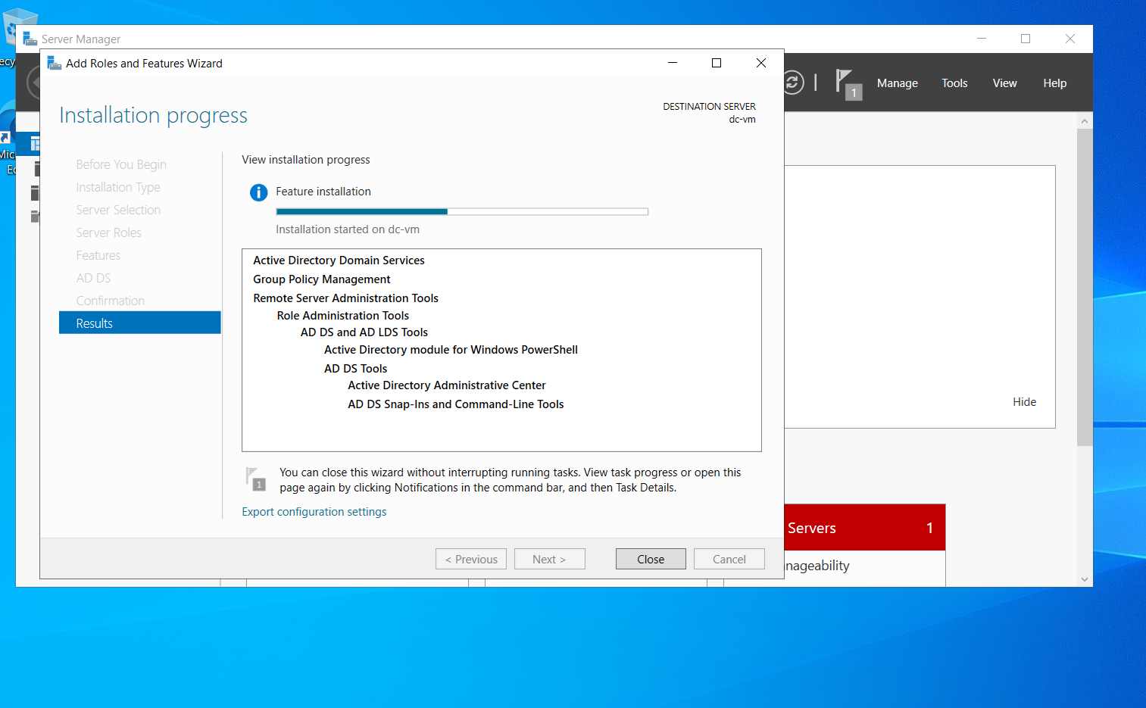

Select this triangle and select promote this server to domain controller

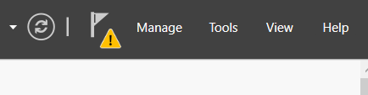

Add new forest

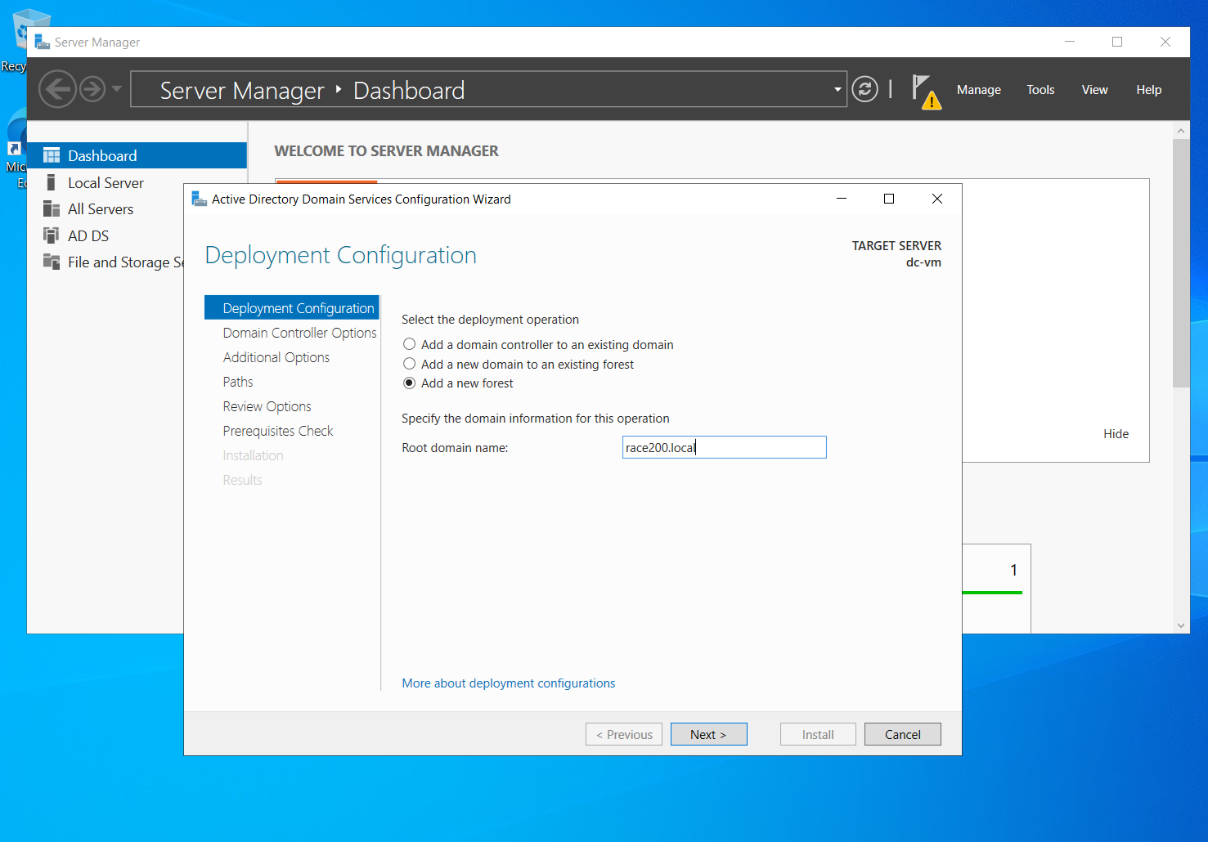

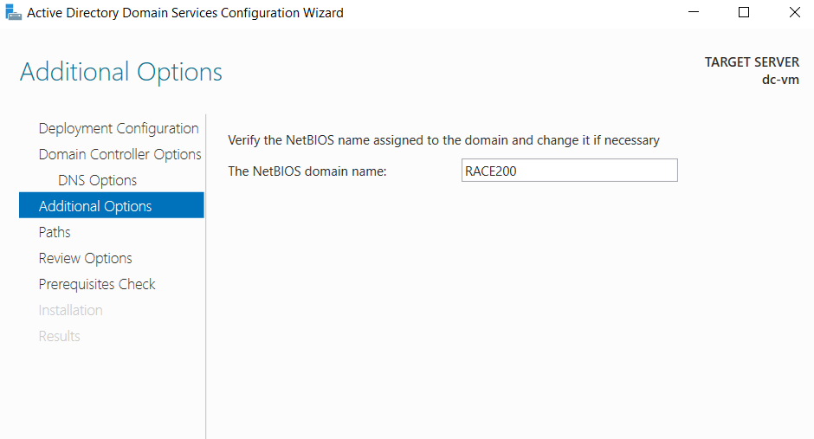

**Windows ADMINISTRATIVE TOOLS**

**Active directory users and computers**

**Domain is created race200.local**

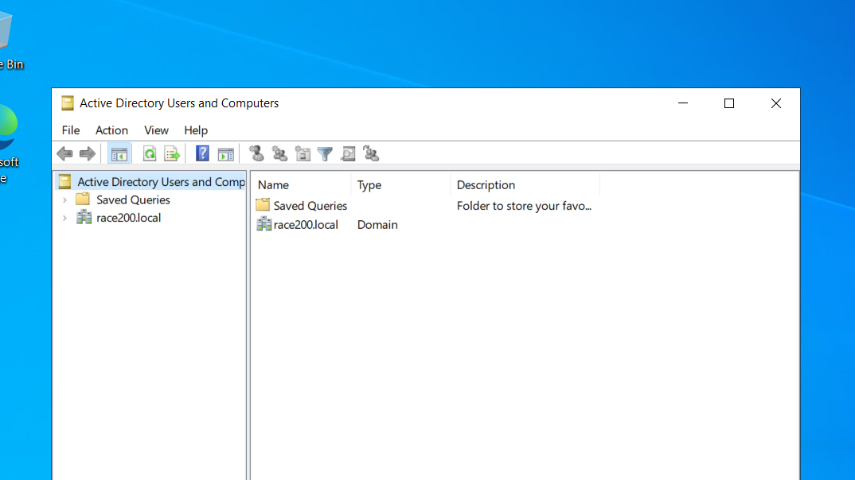

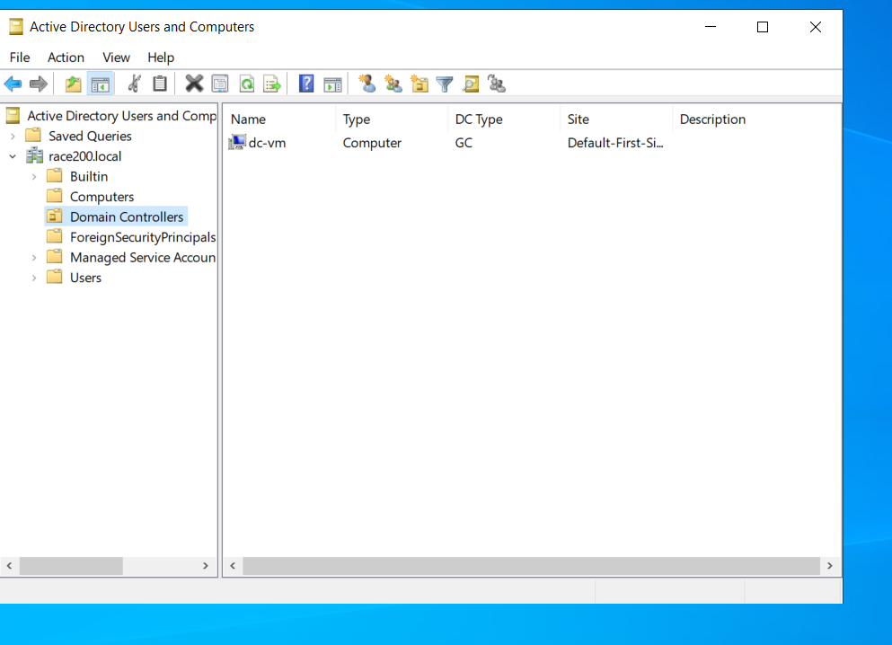

Check computers there are no computers now in the above option

Now adding another computer to this domain like joining

For the initial set up disable windows firewall

Turn Off windows firewall

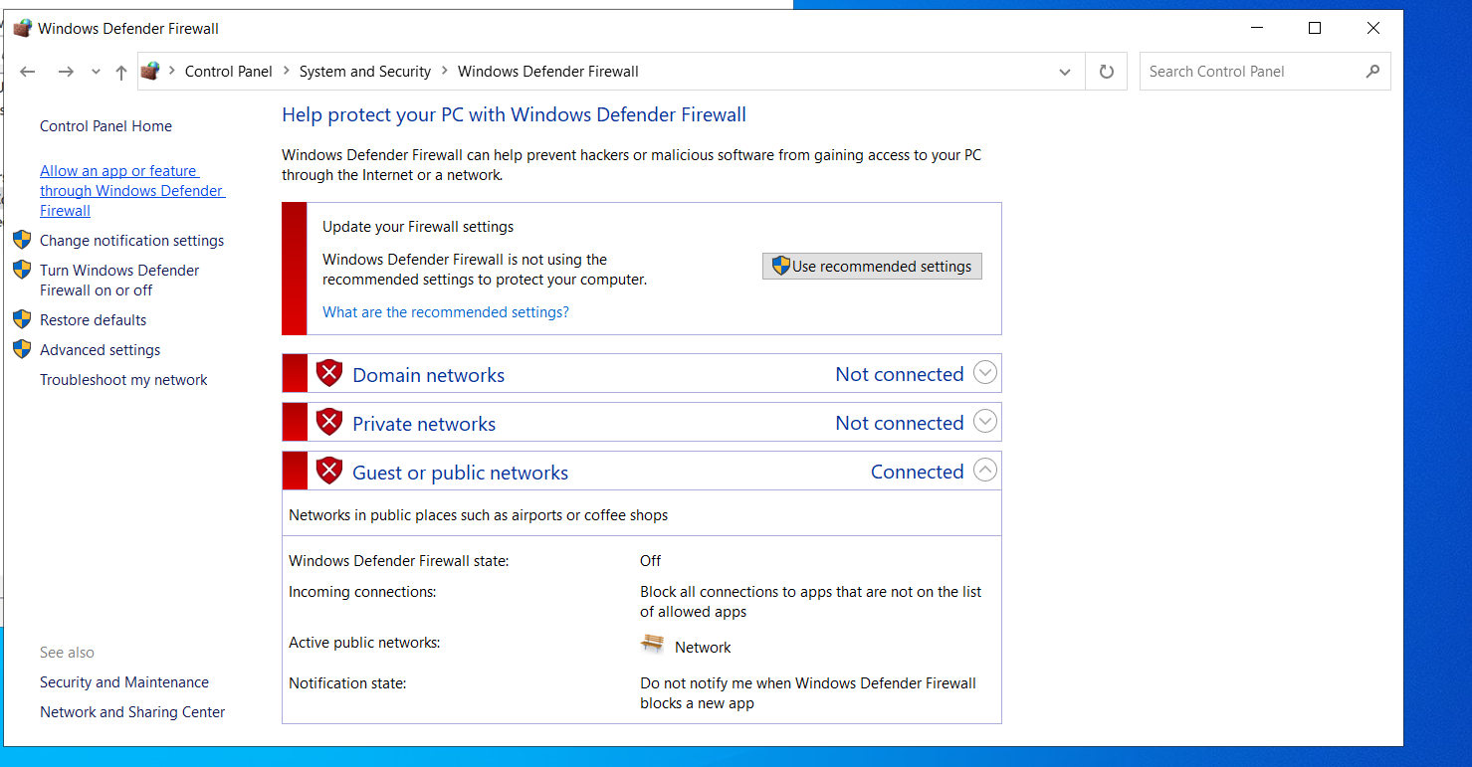

DNS

Any query to the active directory should come to DNS first and from here it will route to active directory

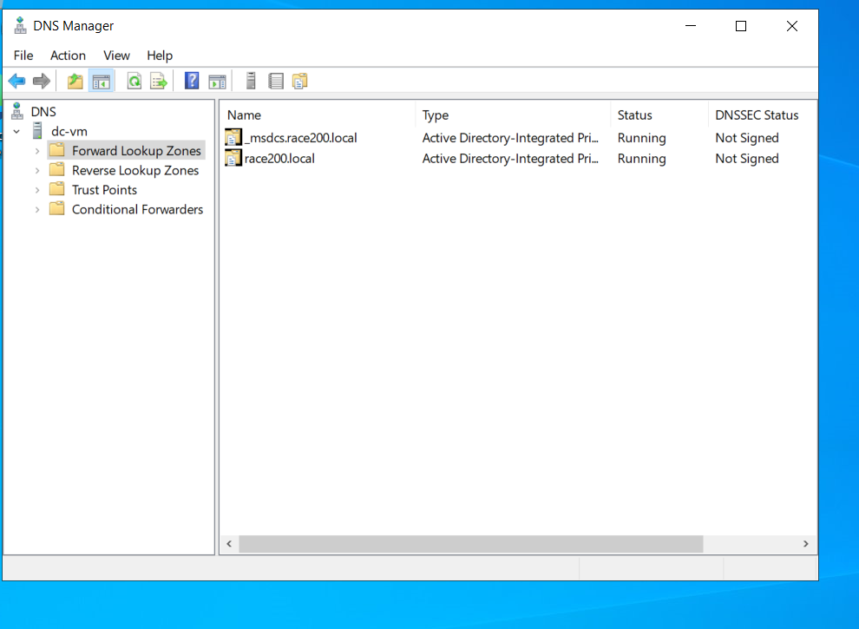

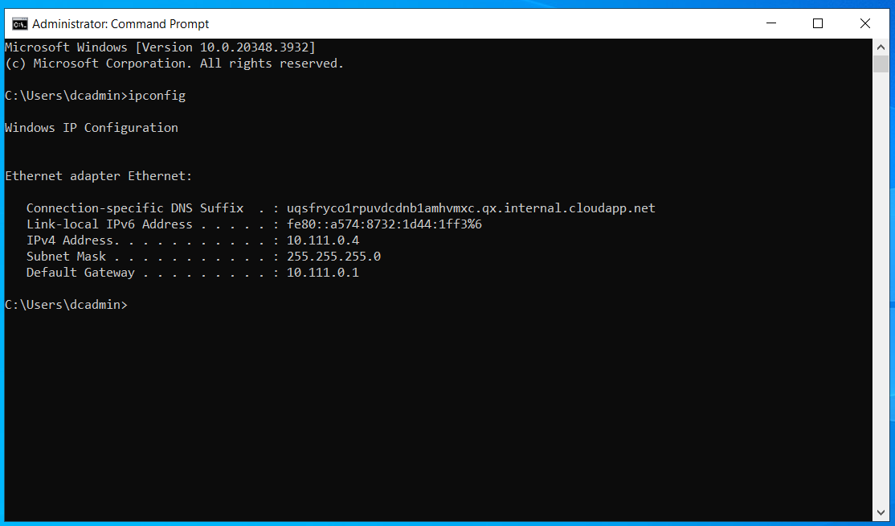

1. **mem-vm should act as client for the DNS server of dc-vm**,

**Hence In mem-vm, Add DNS Server IP address of dc-vm Private ip**

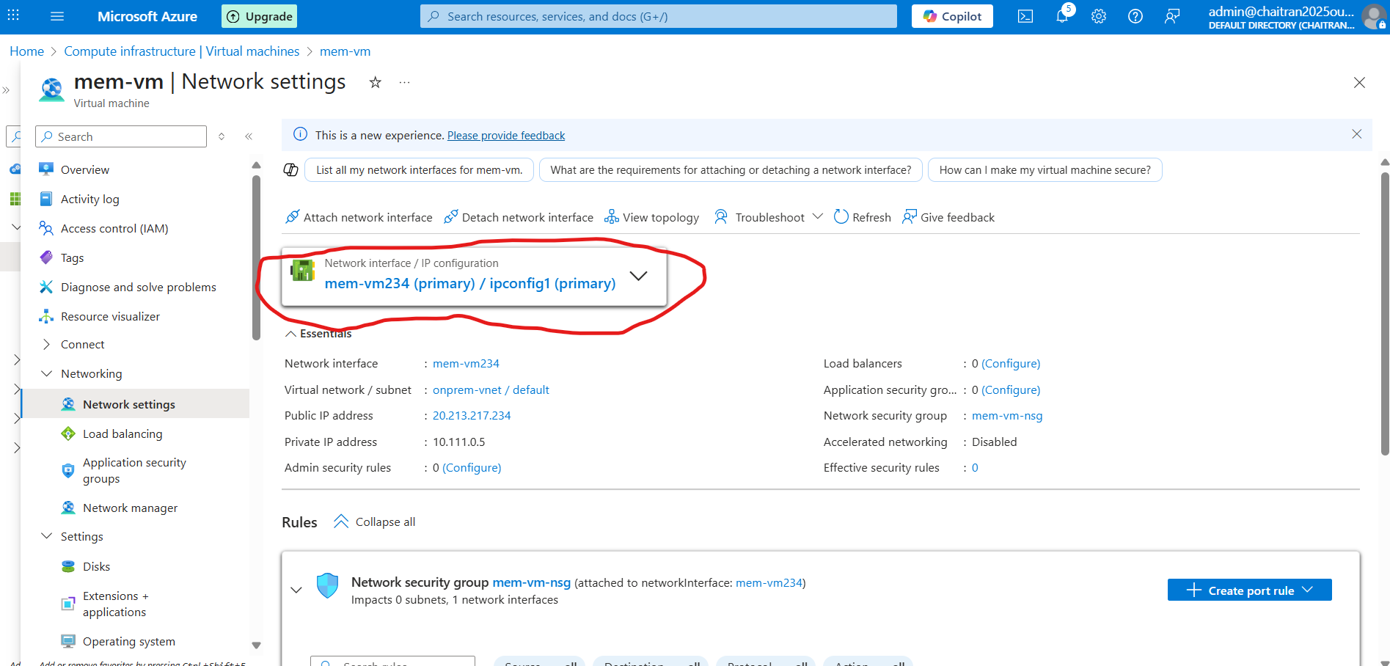

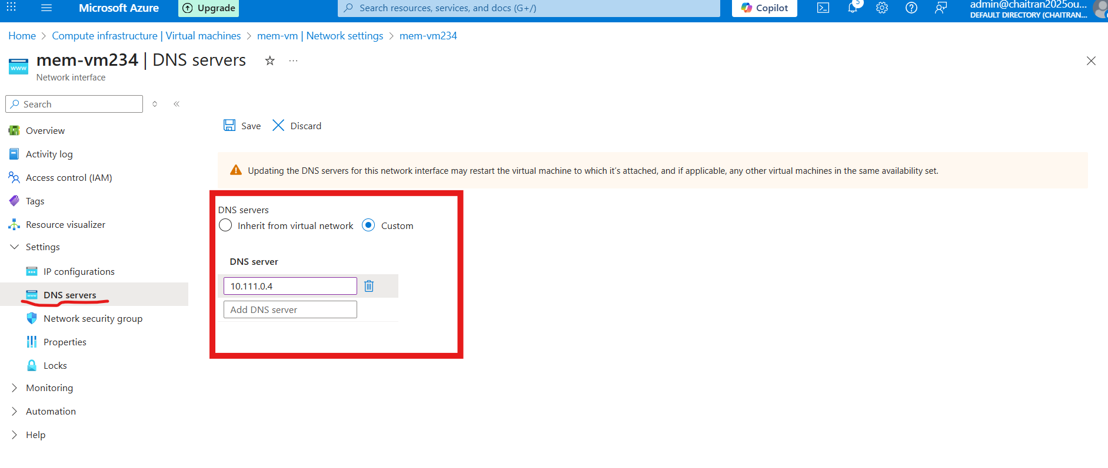

**DNS Server – Change from Inherit to custom**

**Add DNS Server IP address of dc-vm private ip**

1. **Access the mem-vm using Public ip via RDP**

Using public ip of mem-vm

memadmin and password

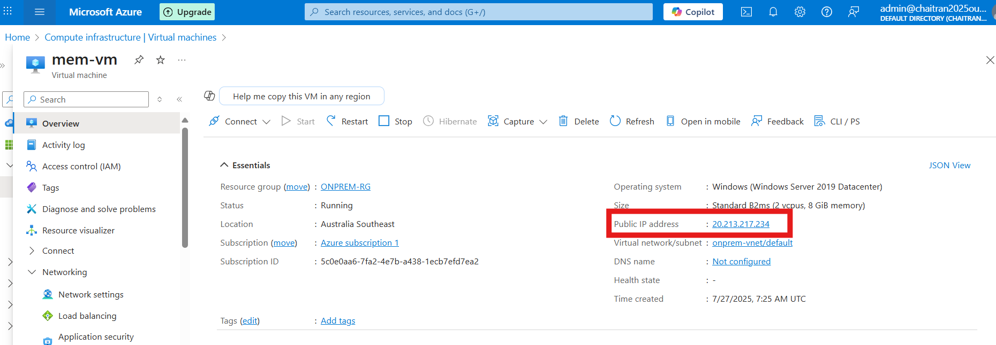

**Ping and check in power shell**

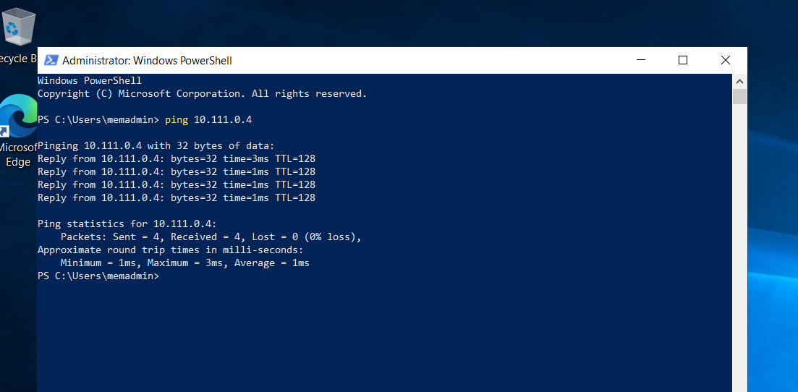

**Now disable windows firewall here as well**

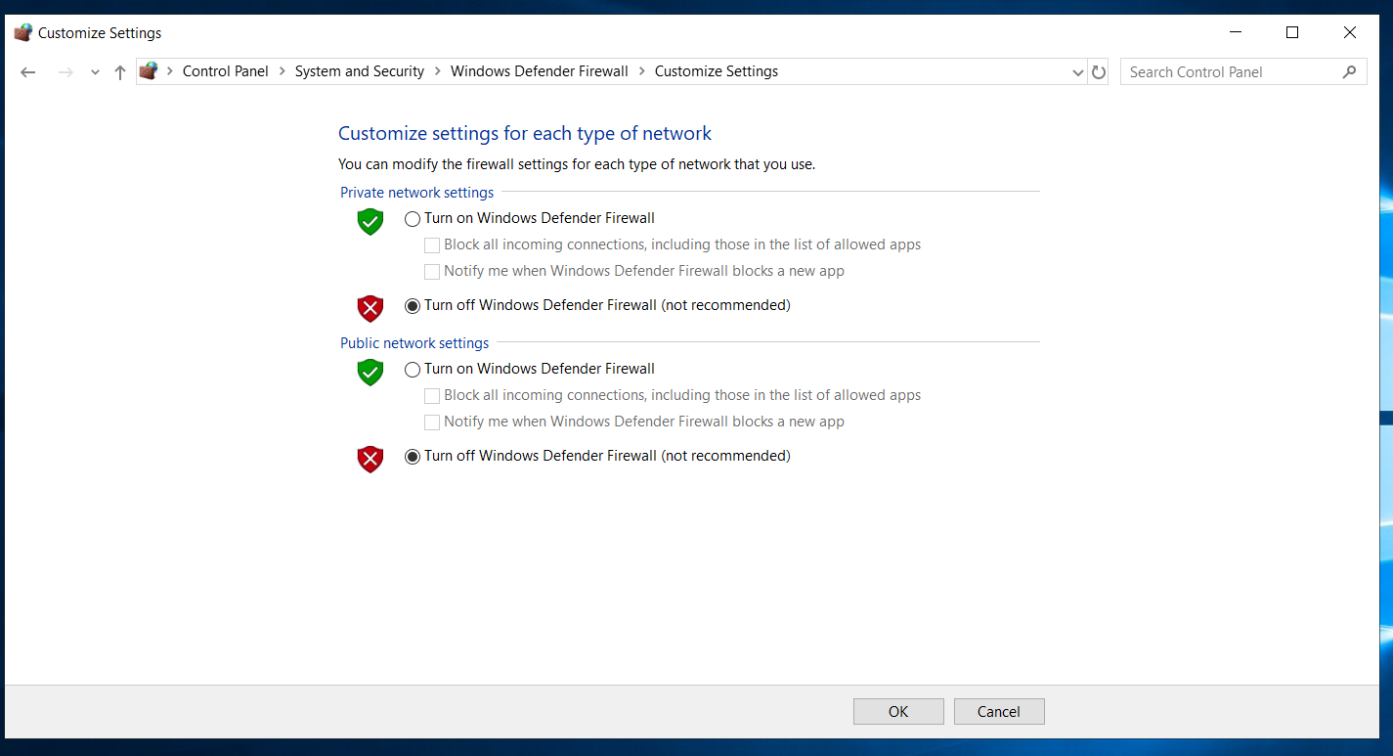

Since already configured client domain with dc domain as DNS server should be able to ping race200.local

Below is the screenshot of the reply from dc-vm

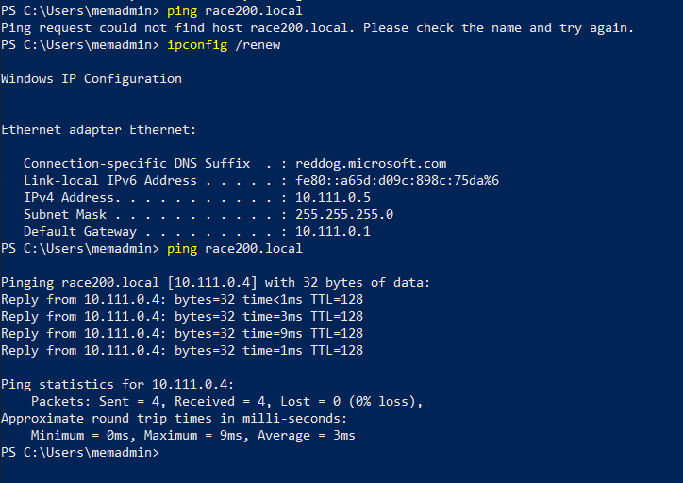

Change from workgroup to domain

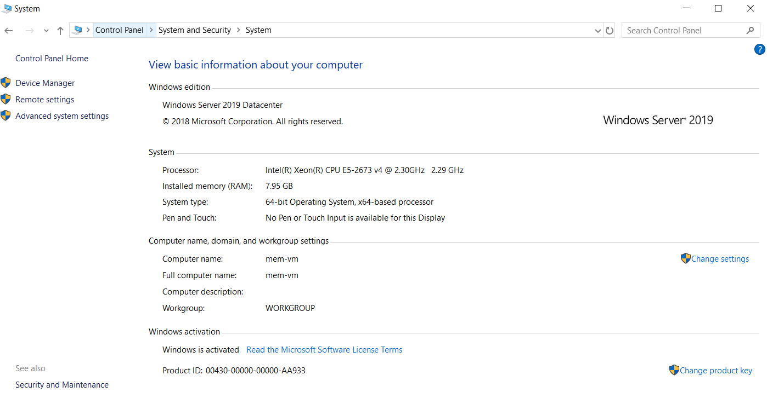

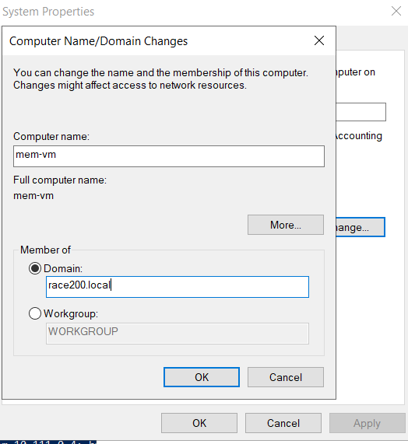

Then it asks for the permission

Provide the dcadmin permission

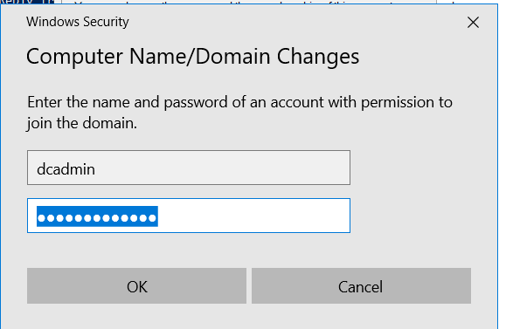

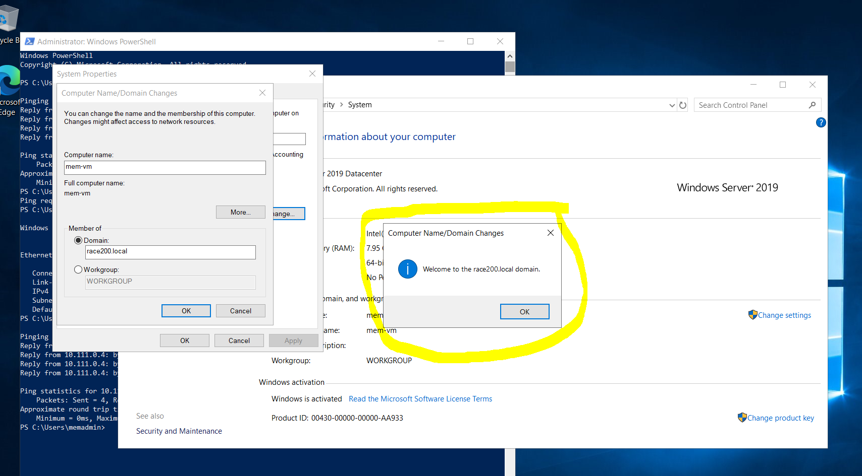

Now it will restart.

1. **Access the mem-vm using Public ip via RDP**

**Login credentials are from domain name and domain account(race200\dcadmin)**

Computer name - (Mem-vm Public IP) - 20.213.217.234

Username – race200\dcadmin

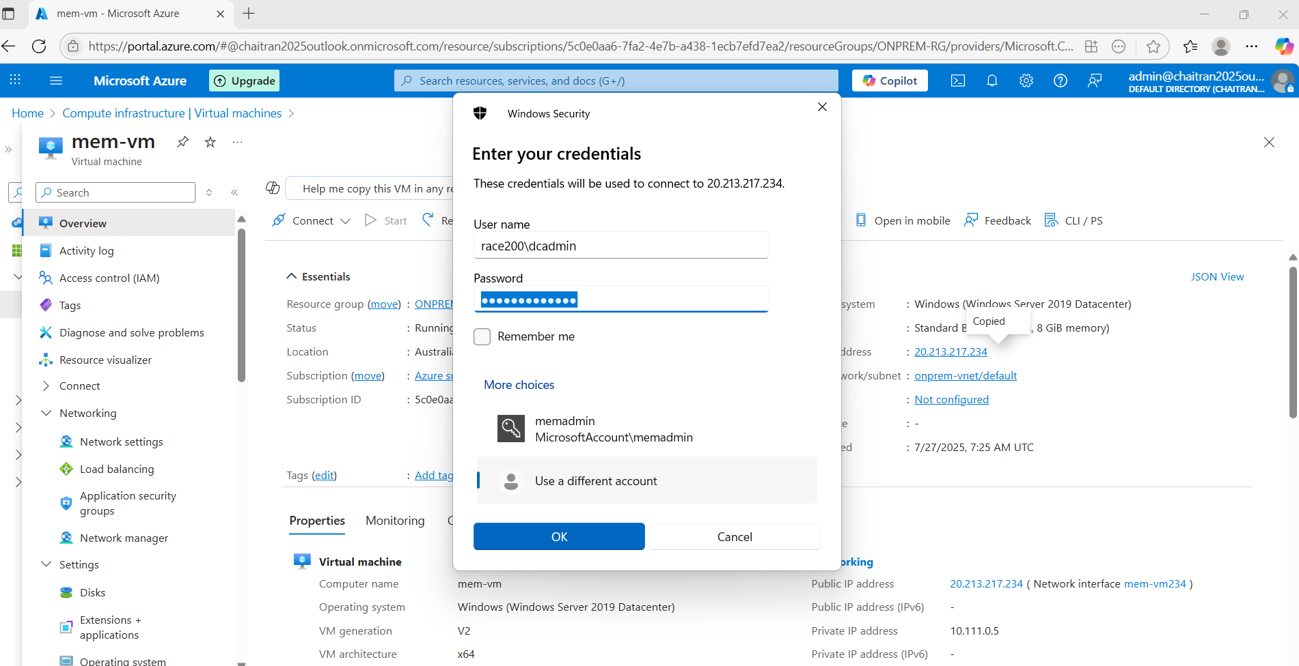

Hence was able to login from mem-vm public IP and Login credentials are from domain name and domain account (Username – race200\dcadmin) as shown in the below screenshot

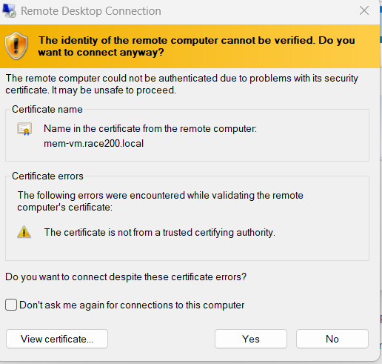

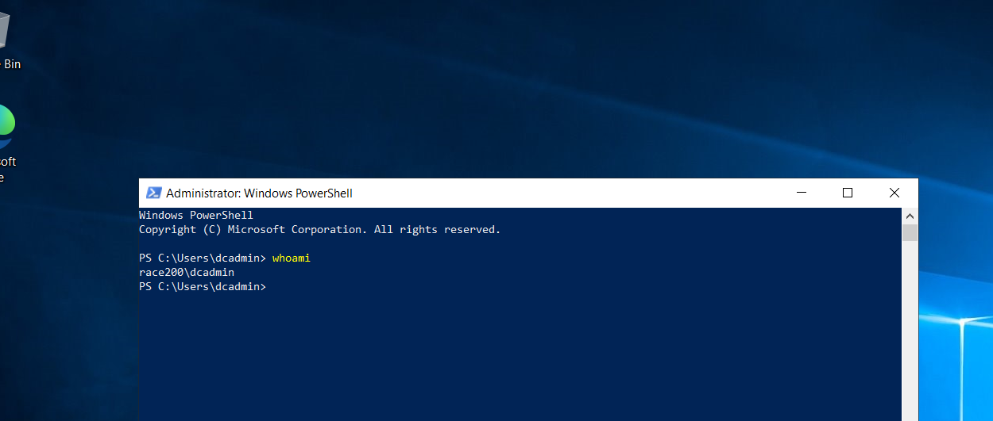

1. **Now in domain control that is in dc-vm**

Under computers the added mem-vm is shown, earlier there was none

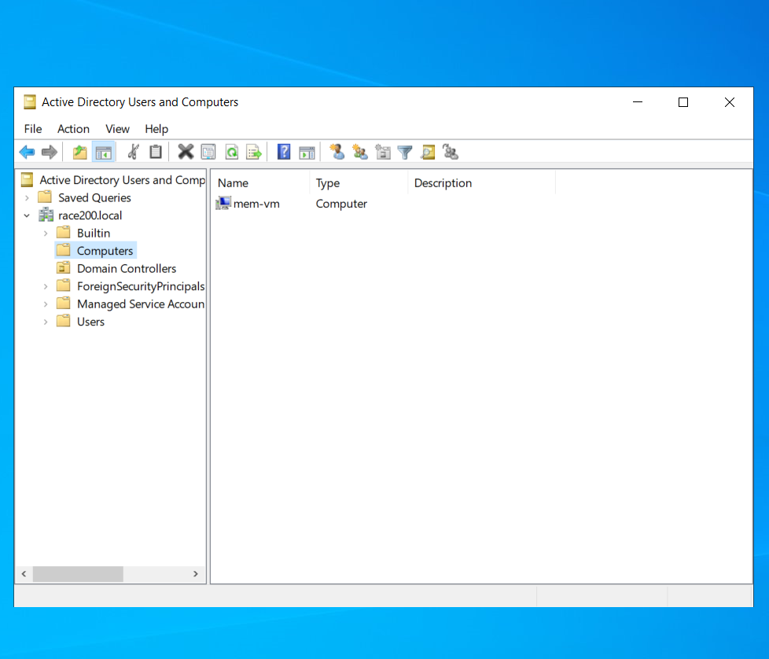

1. **Now in mem-vm one more firewall is provided that is domain network, should disable that as well**

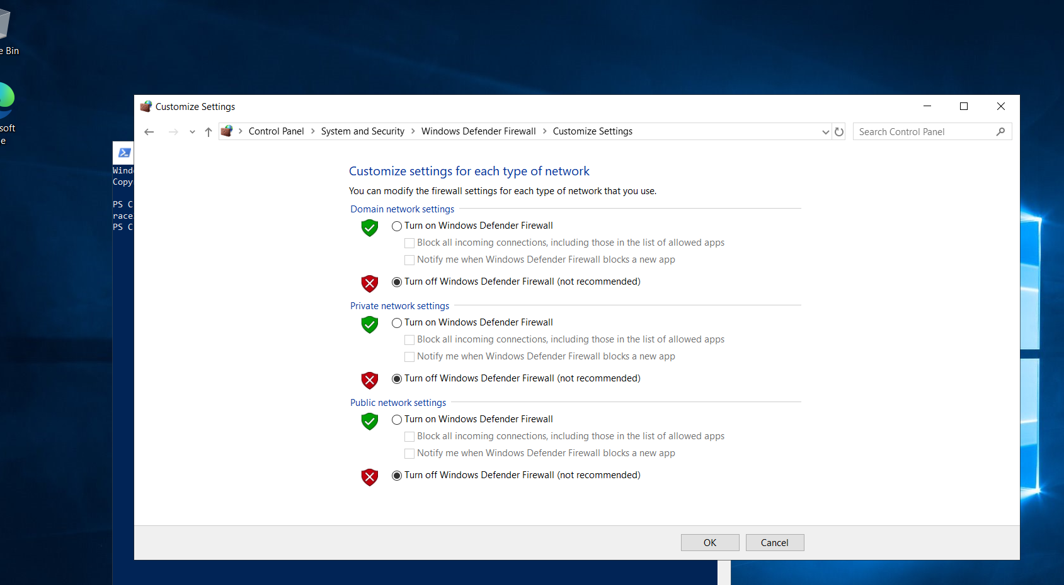

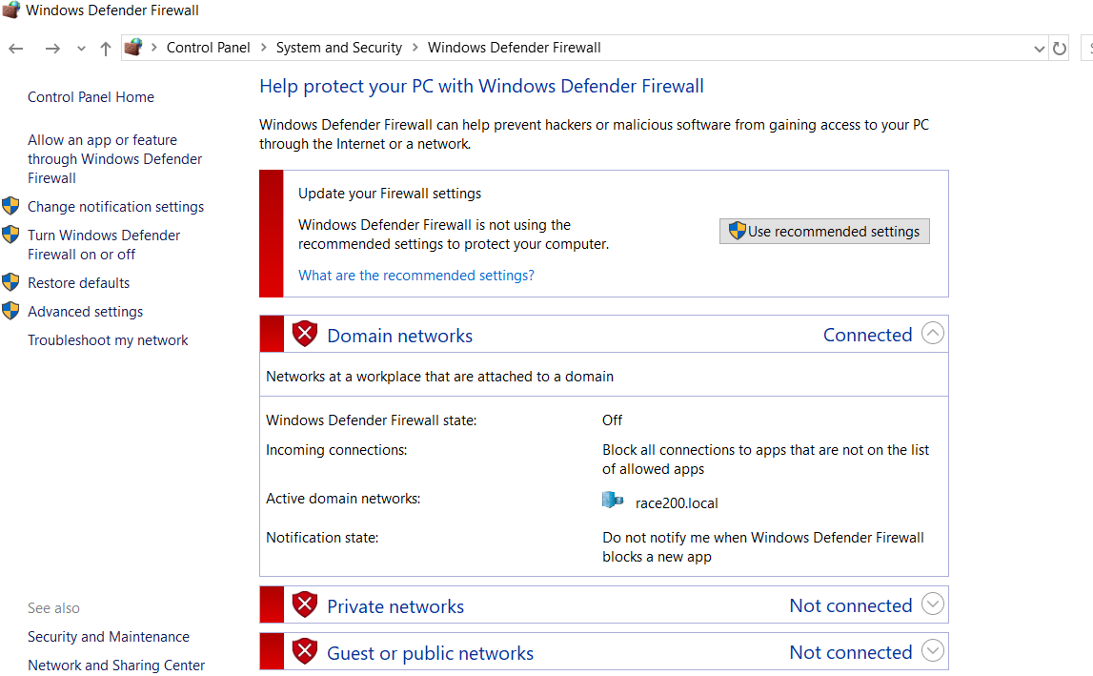

**Now the domain is fully ready , azure is also ready.**

Whatever the new domain is created can bind that to my azure id and the same name can be bind to my onprem as well, as Azure id subscription should have your organisation domain name.

1. **To Bind**

First Buy Domain from Big rock

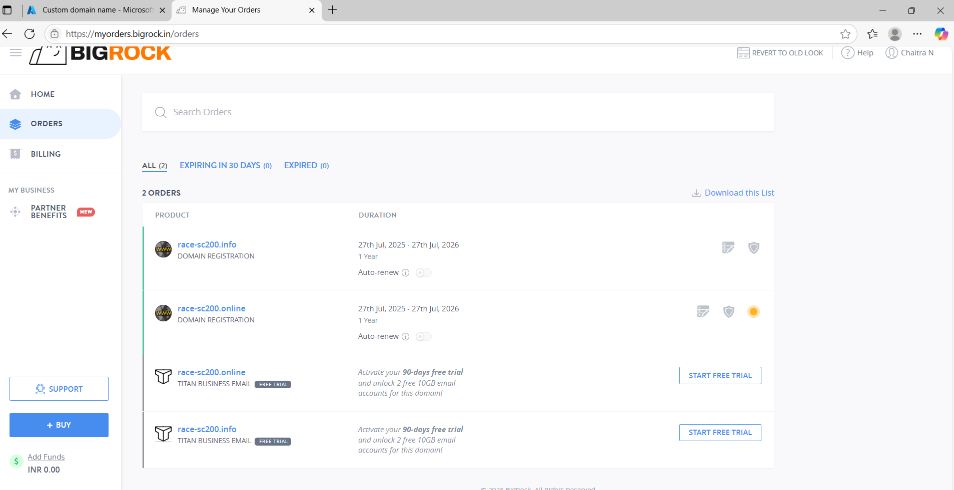

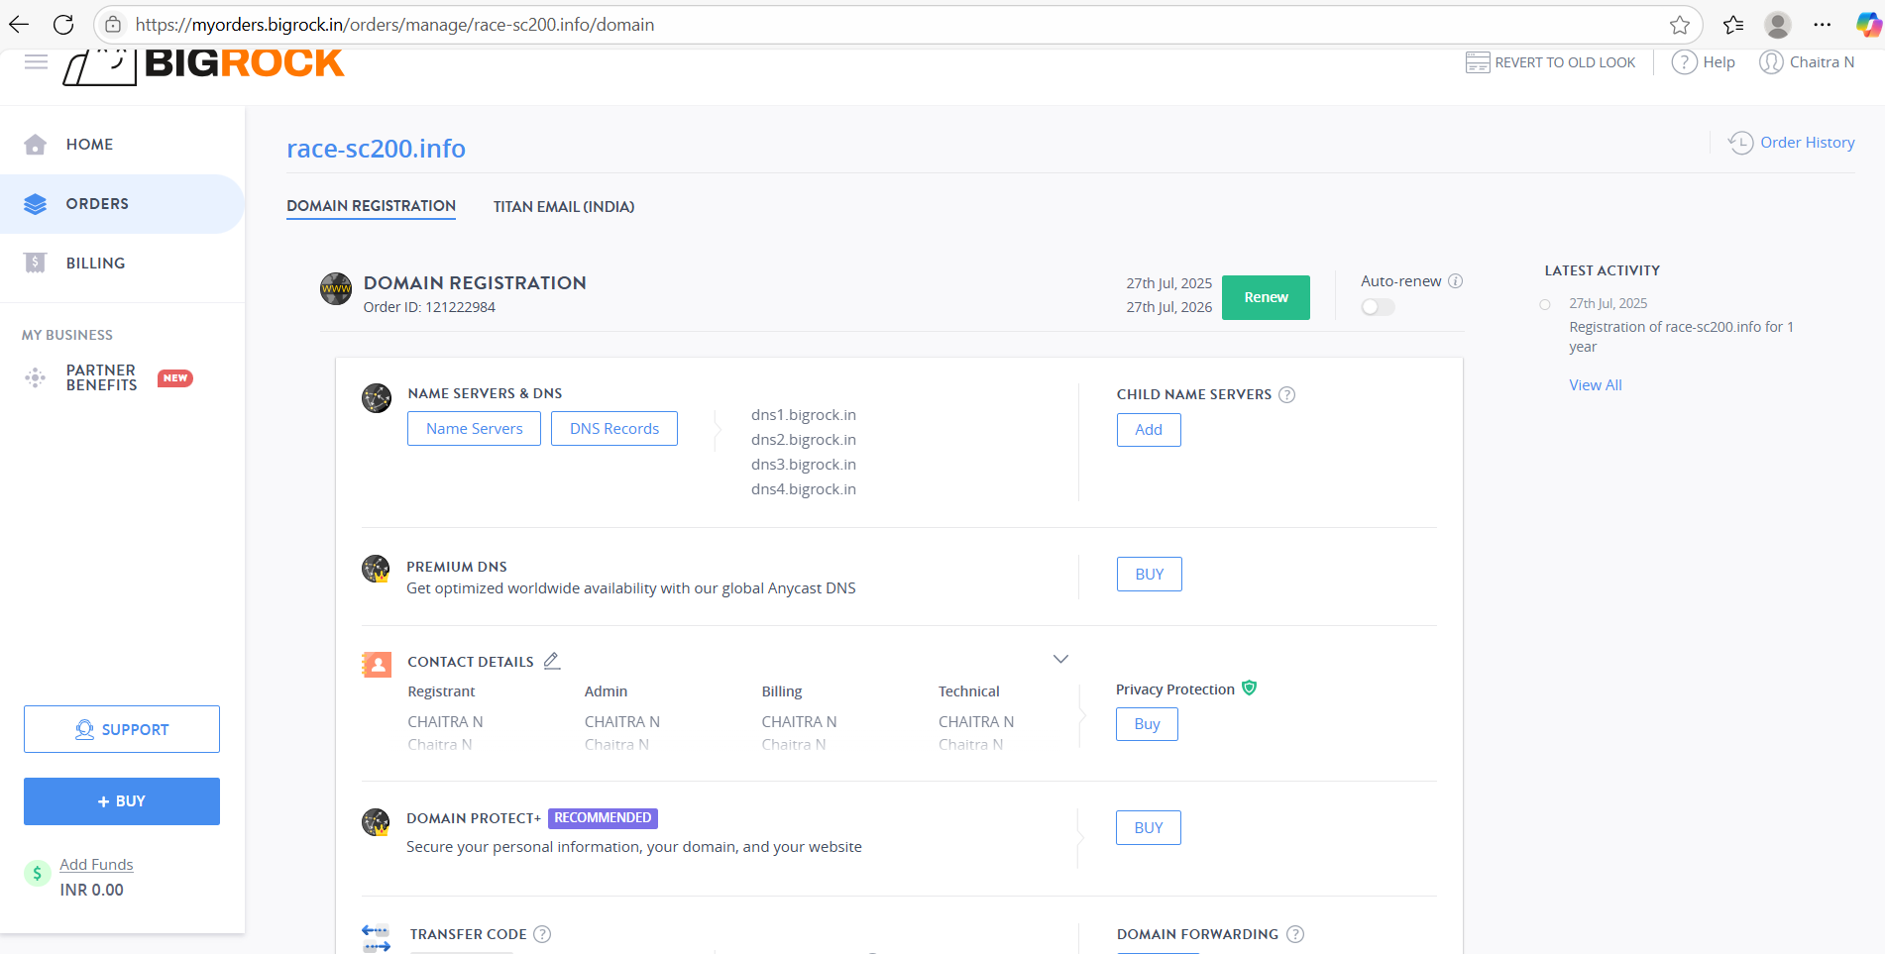

Click on DNS Records

Goto Azure, Microsoft Entra id, custom domain names

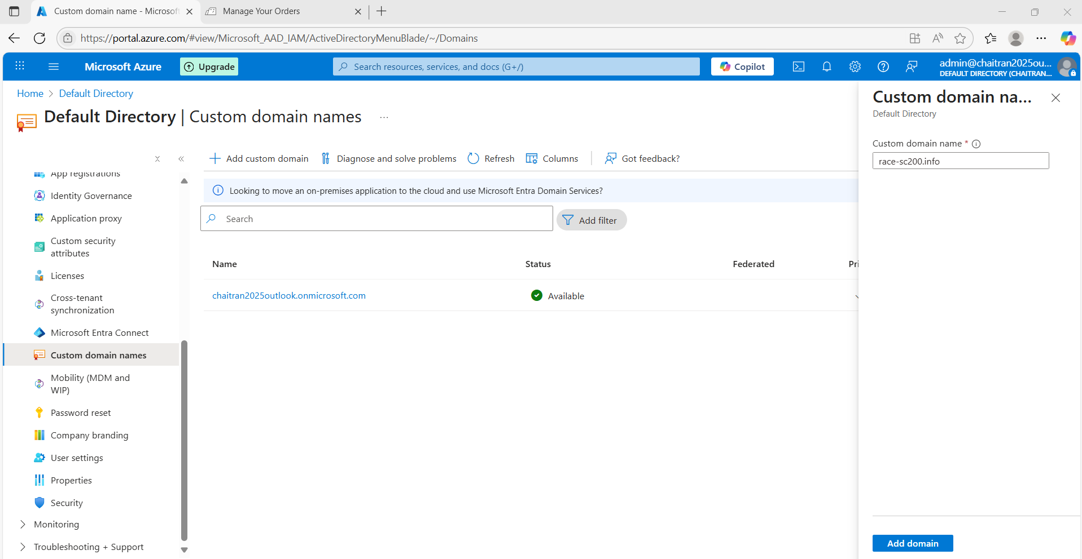

Add custom domain – race-sc200.info

Now domain name is added, it has to be verified

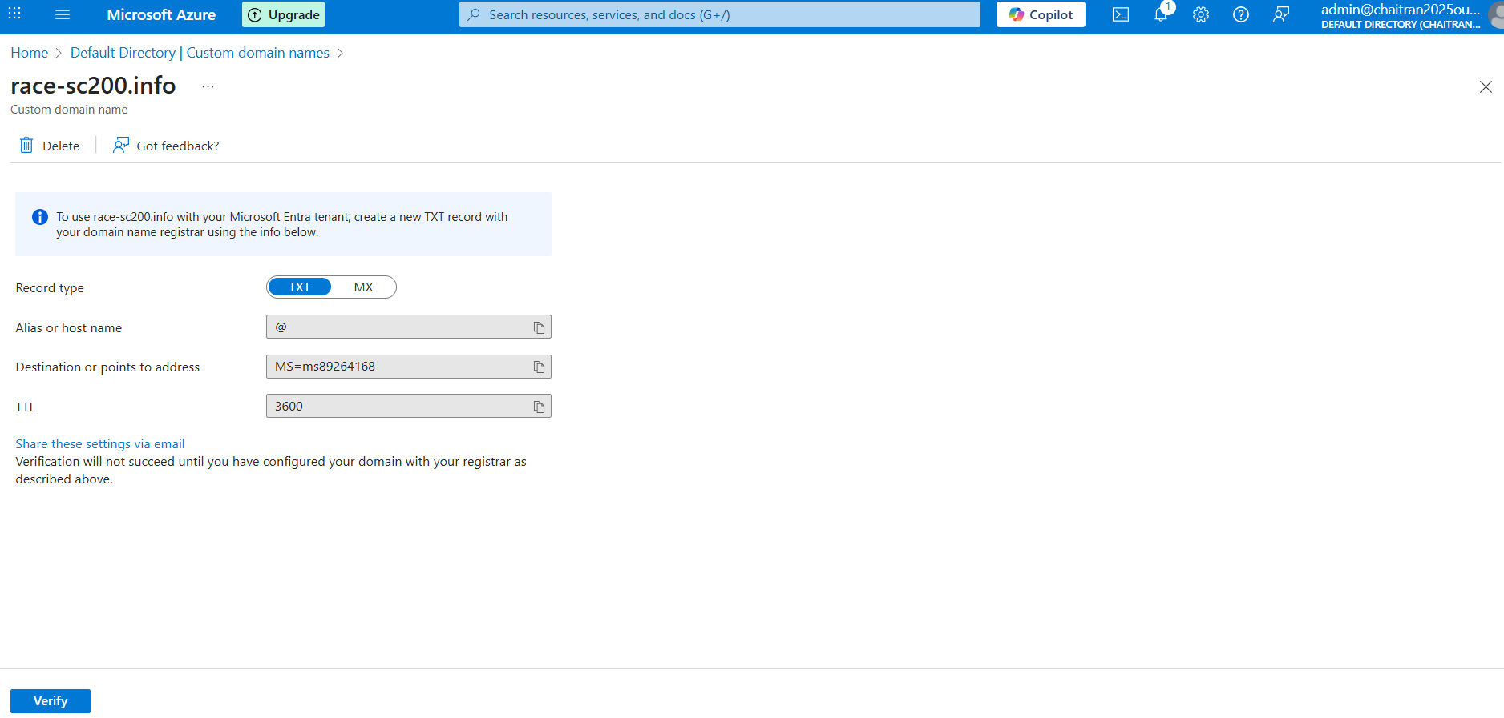

Click on records in bigrock and compare from azure and bigrock and verify.

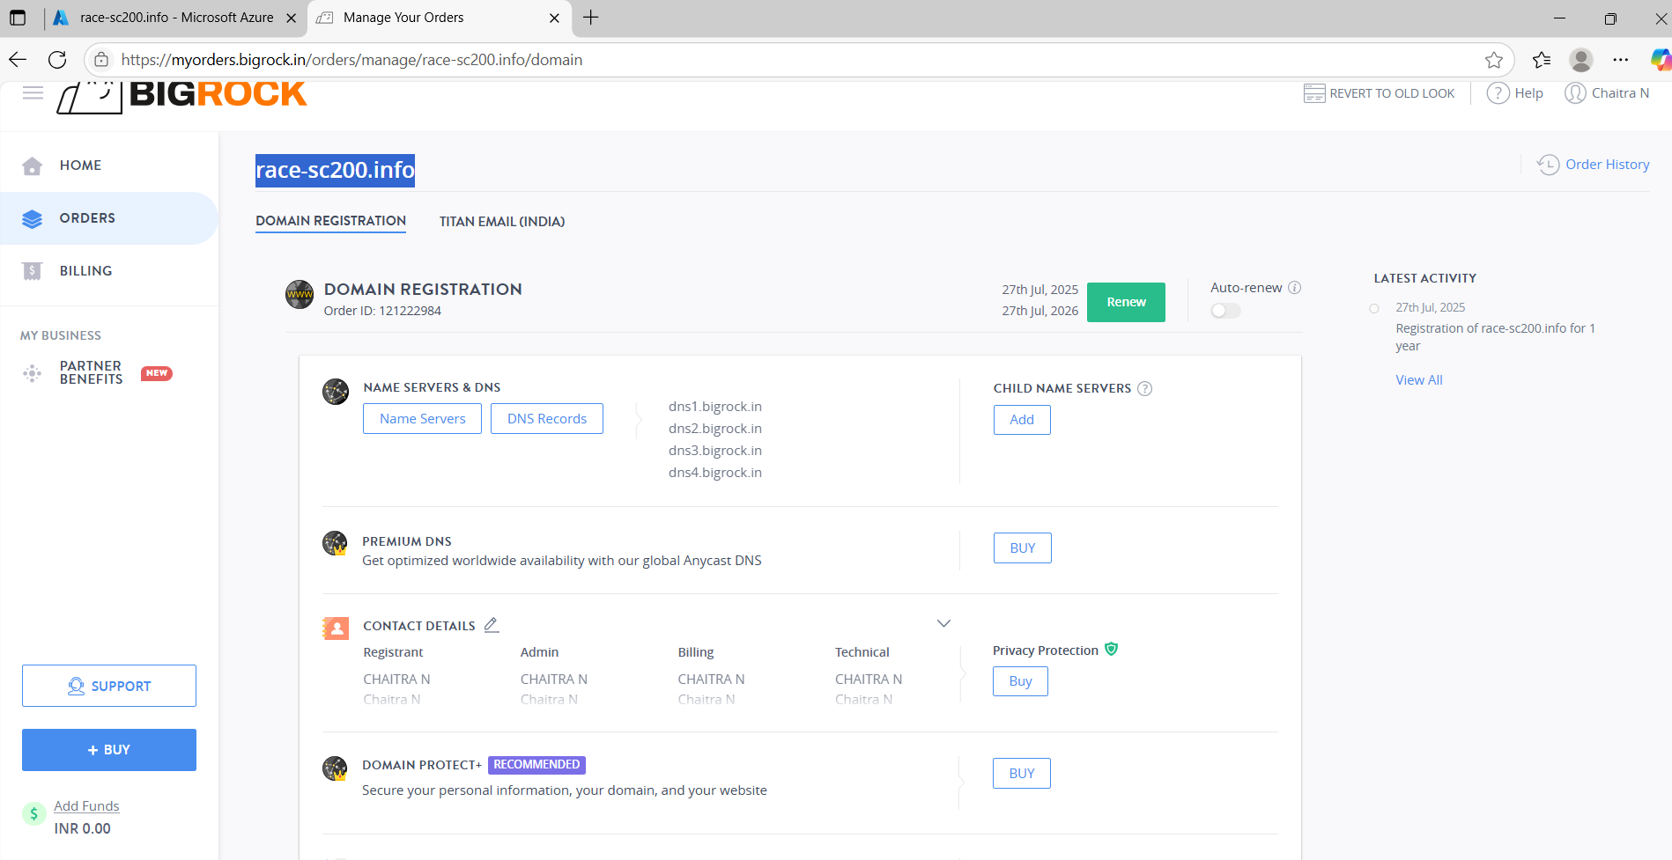

Added MX and TXT

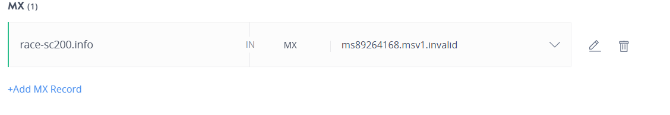

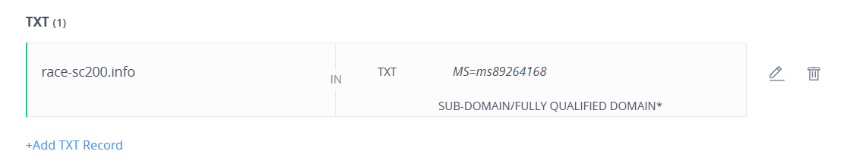

Now verify in azure

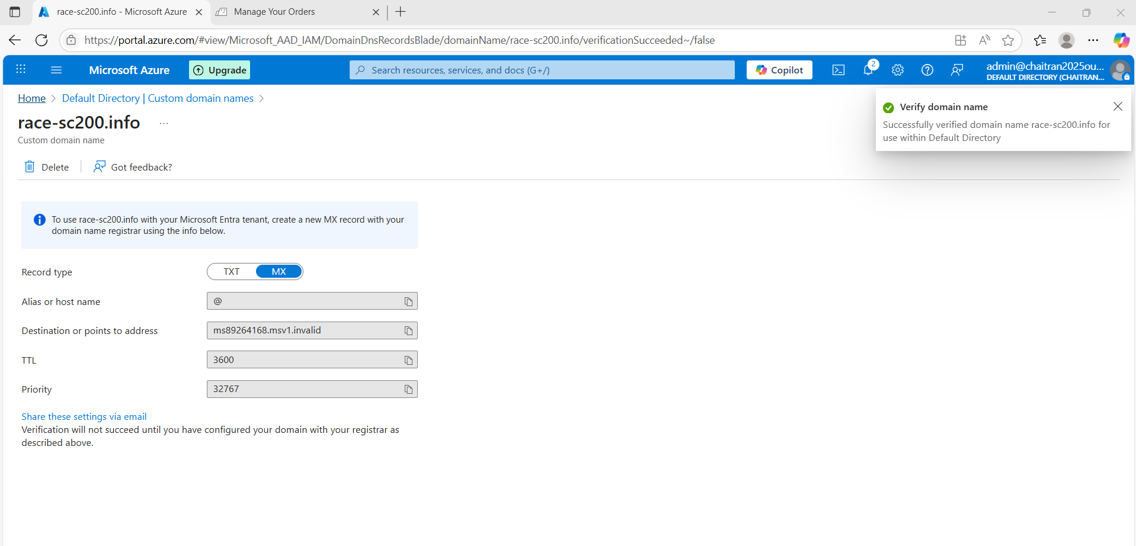

Now race-sc200.info is binded with azure is shown in below screenshot

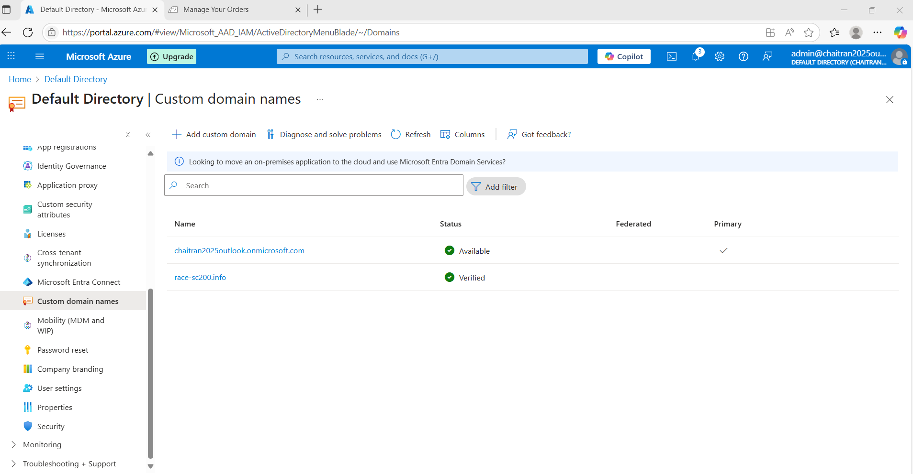

Note: Always in the production will have custom domains only

Which means here can use race-sc200.info as domain.

1. Now same thing should be added to the domain level

Access RDP in dc-vm

Select Active directory domains and trusts – right click and select properties

Provide User Principal name, Given same domain name and add – apply and ok

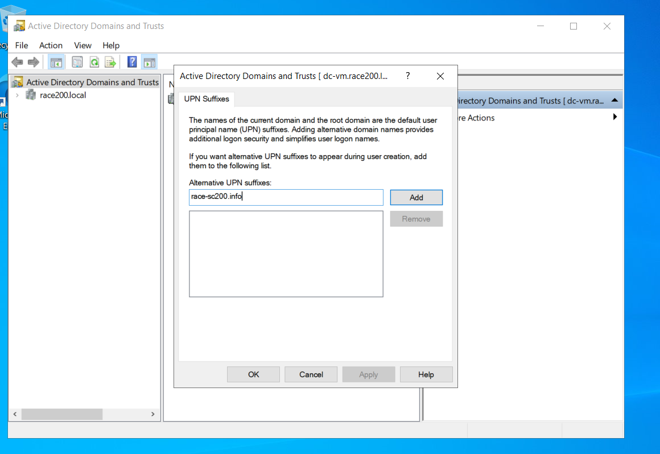

Now goto active directory users and computers

Create users

Right click on users and create new users

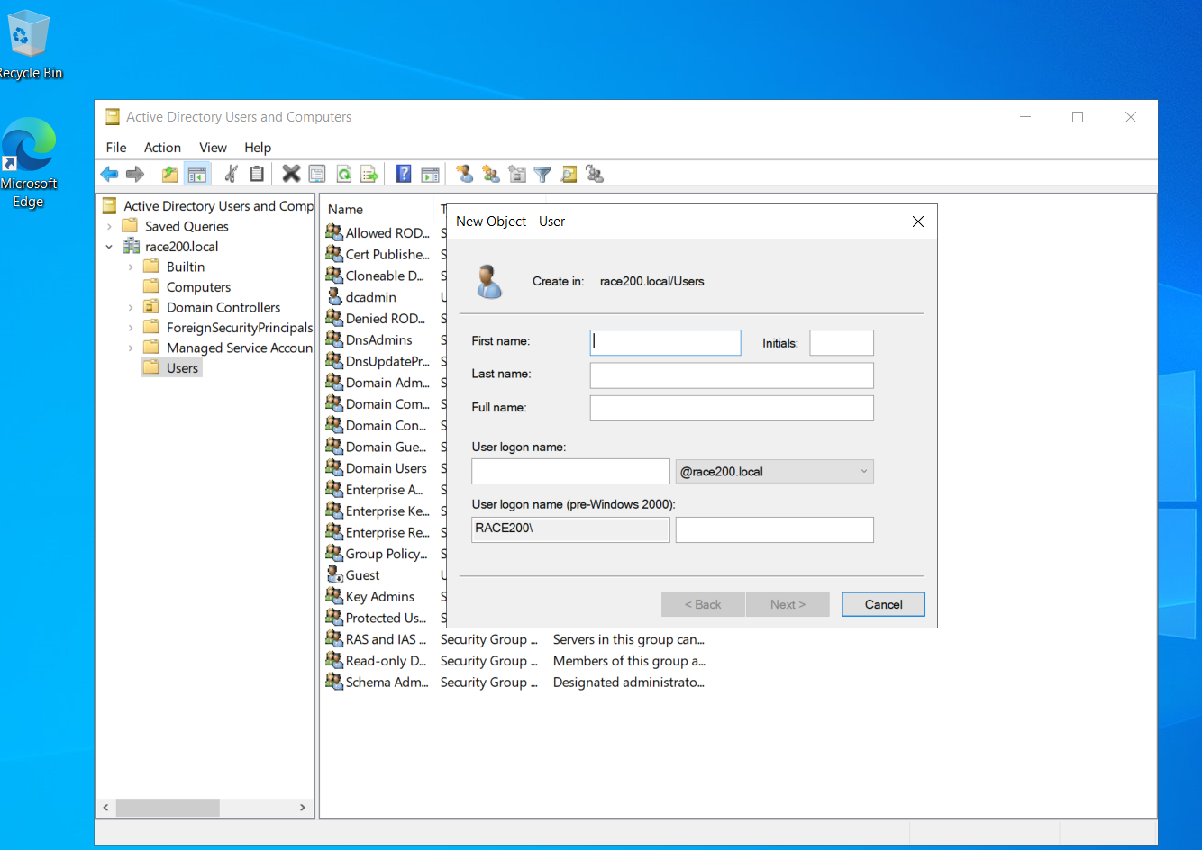

We need not to modify own domain like racesc200.local instead can have new organisational level domain as race-sc200.info under UPI

Since I don’t want to synchronize all the users, I’ll create one OU (Organizational unit)

Here created OU named as **hybridusers**.

To create goto active directory users and computers, right click on race200.local and select organizational unit, name it and press OK.

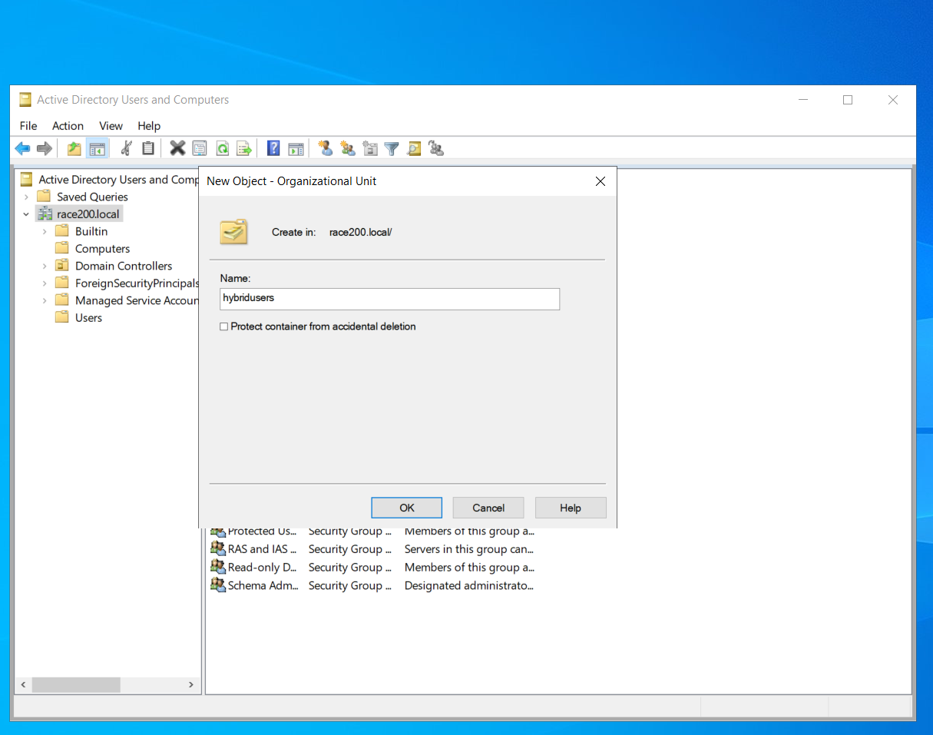

Right click on hybridusers and select create new users and create new users

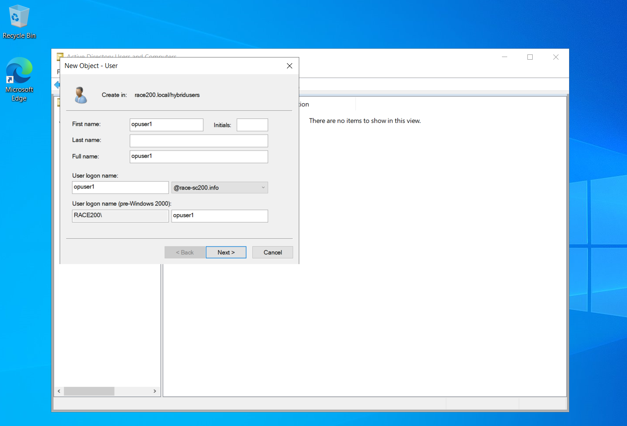

Give password and create

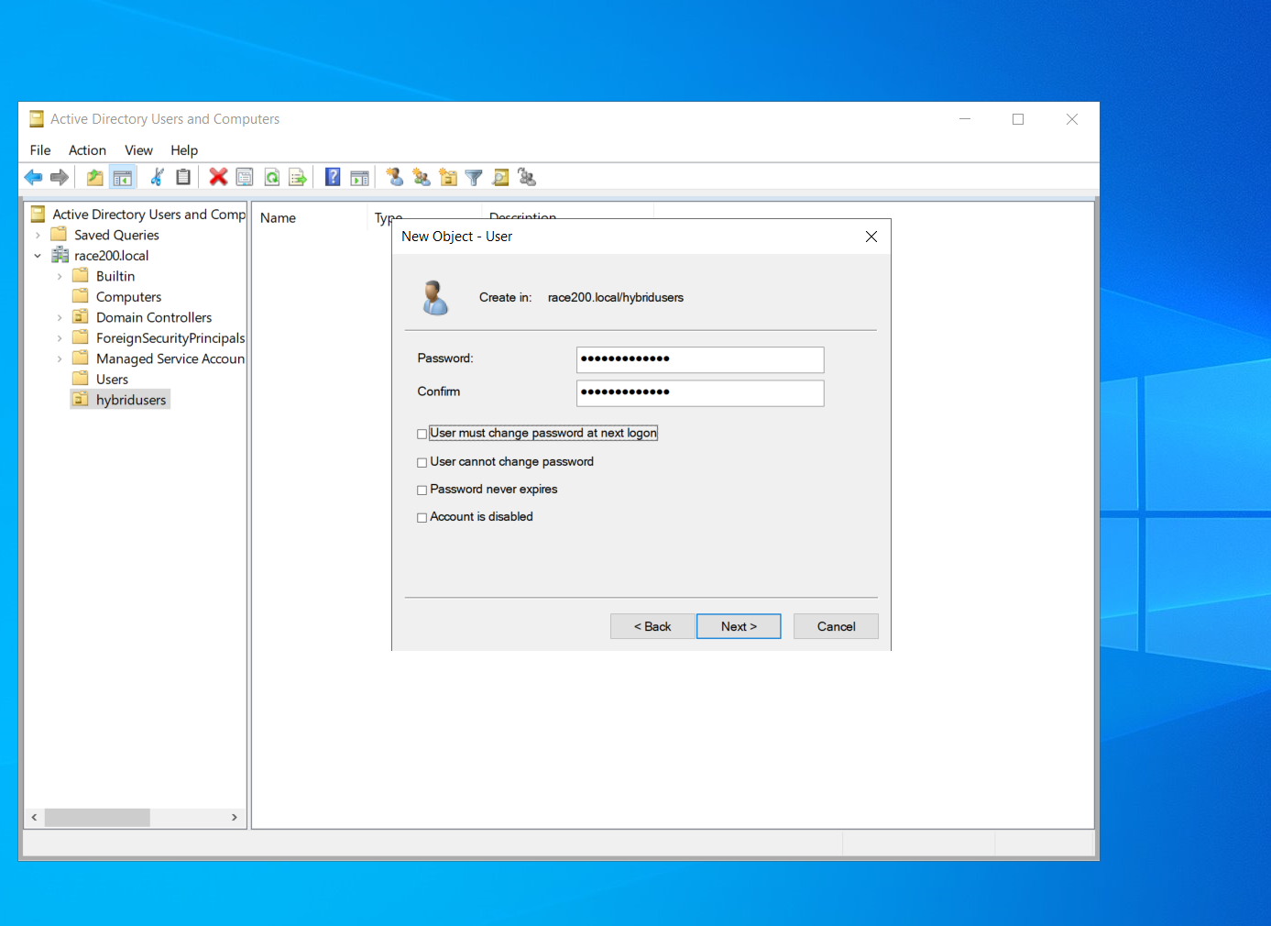

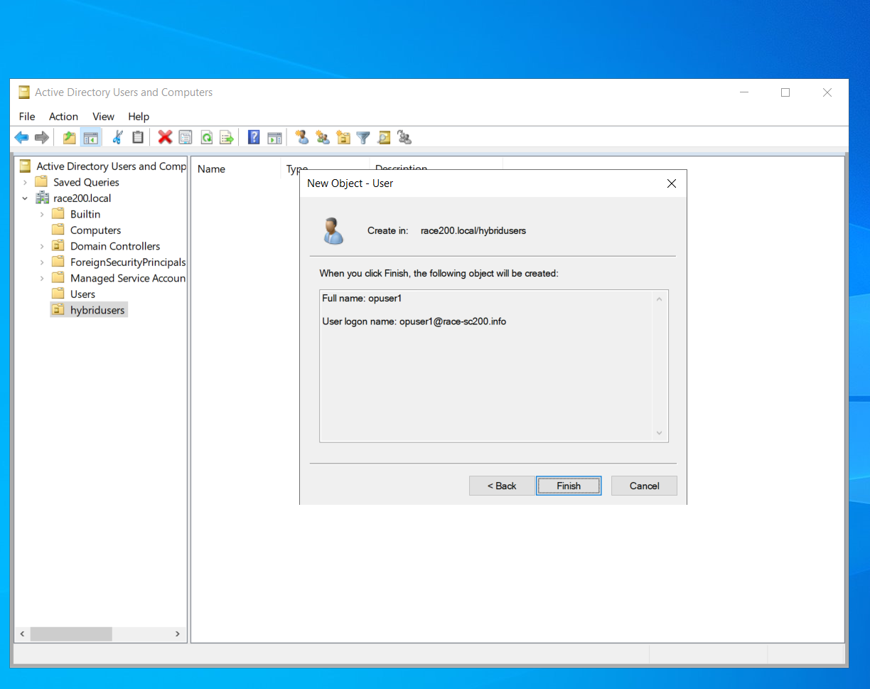

Likewise can create many users in hybridusers and domain race-sc200.info and synchronize.

Here I will Sync only these users (Cloud Sync) and provide Single sign (PTA) only to these users.

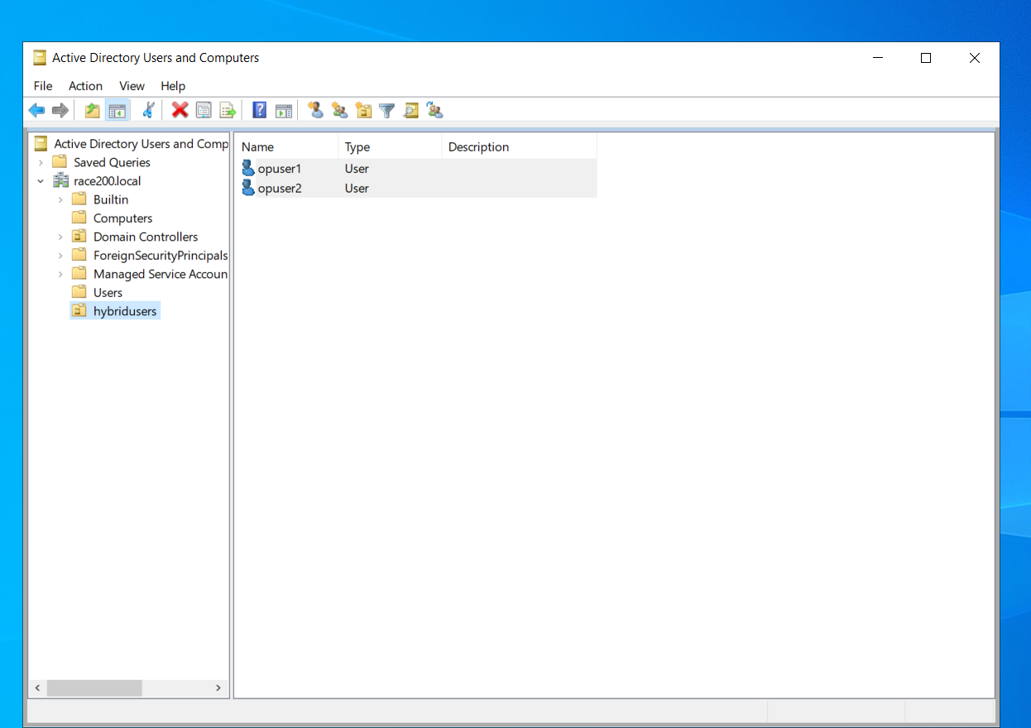

1. **SPLIT DNS CONFIGURATION**

mem-vm public ip is added in bigrock DNS as a record

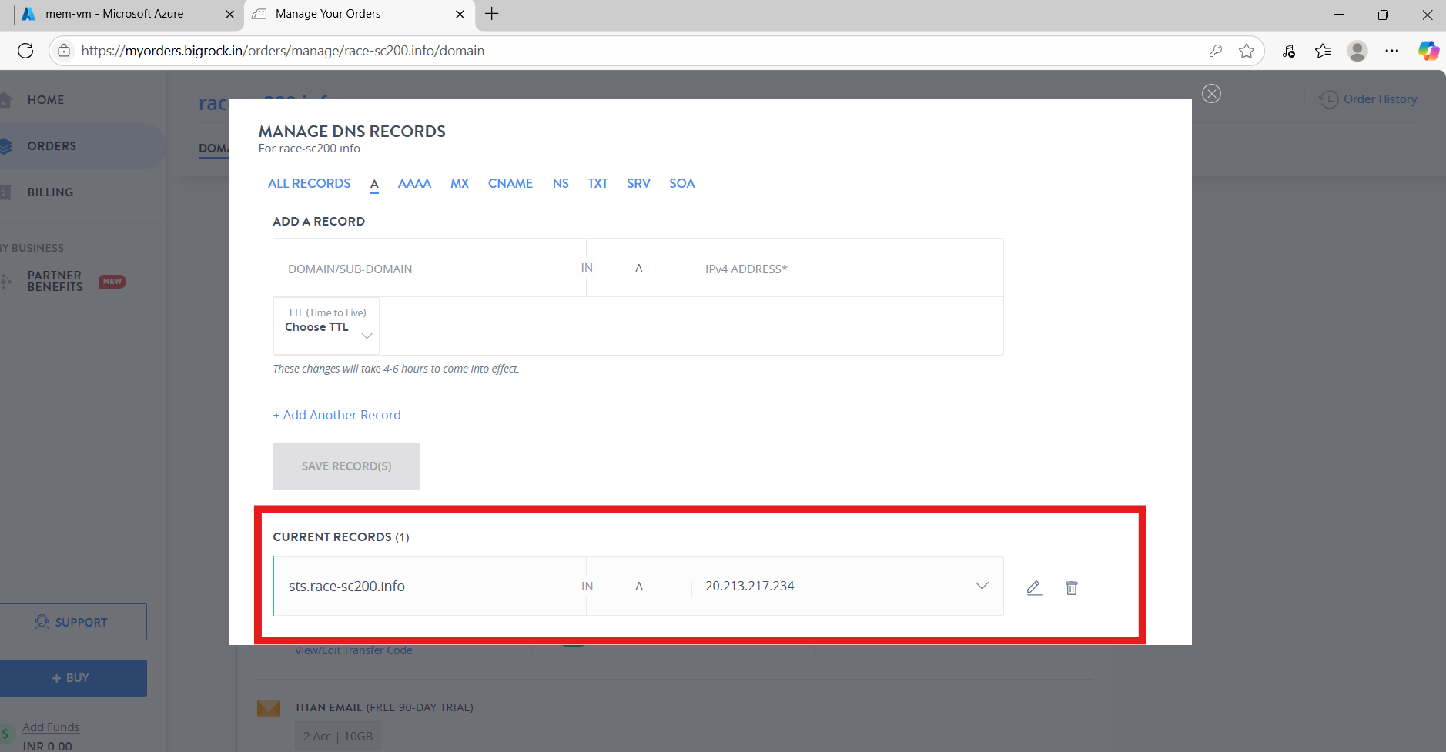

Here STS.race-sc200.info from outside it will resolve to the public ip.

Now in dc-vm

In DNS there was no domain name race-sc200.info, hence create it

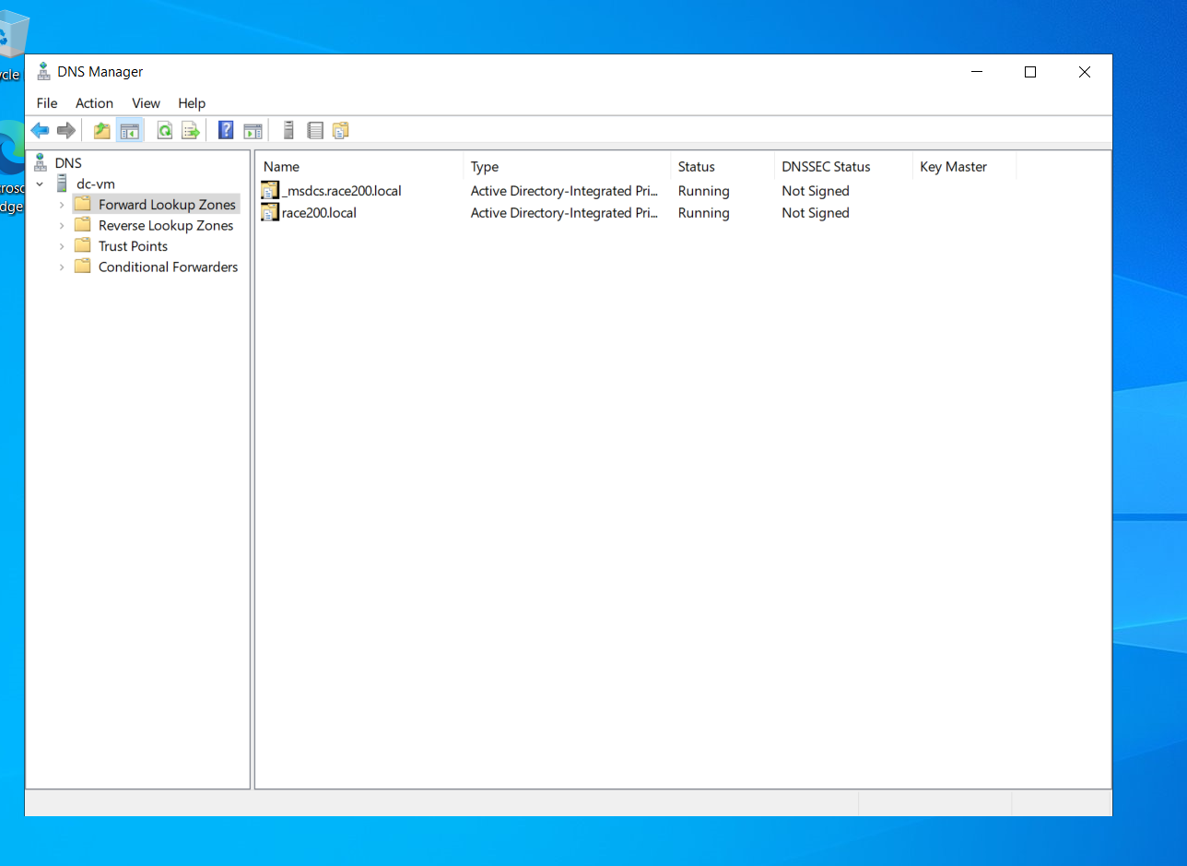

Create new zone

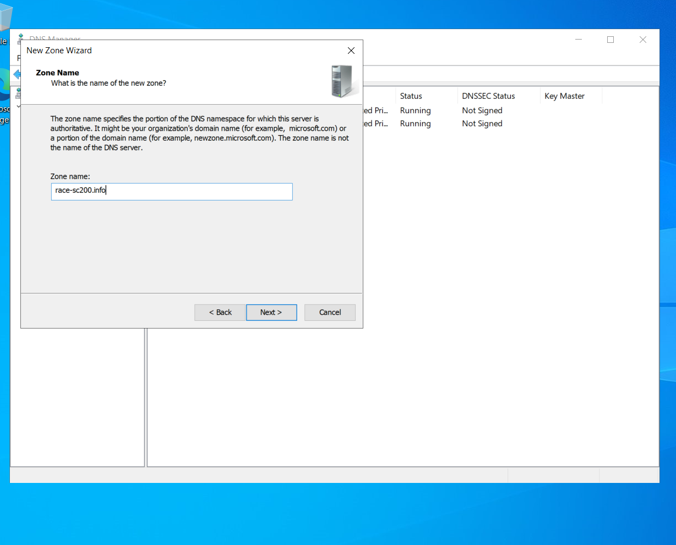

It is created

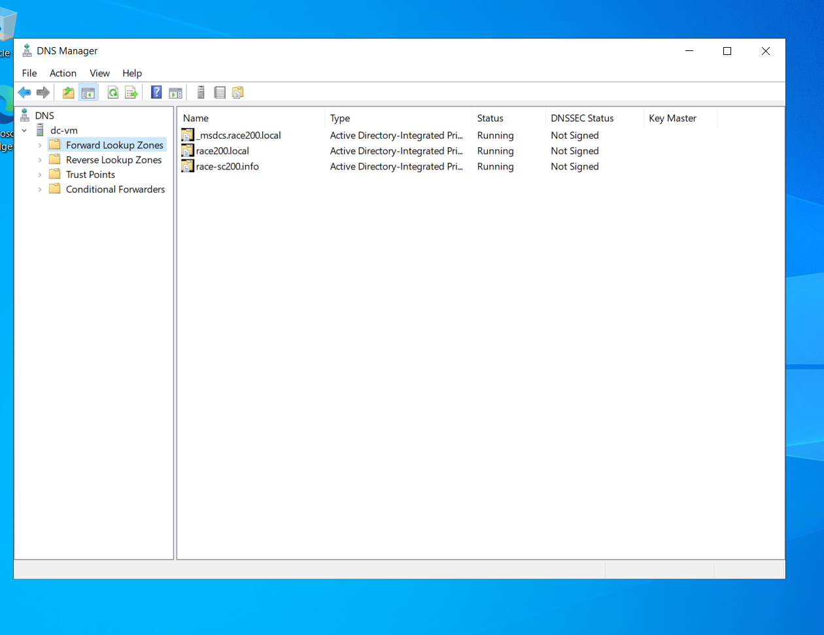

Right click on race-sc200.info and host new zone as **sts.race-sc200.info,**

Use Private IP of mem-vm and finish. Below is the screenshot.

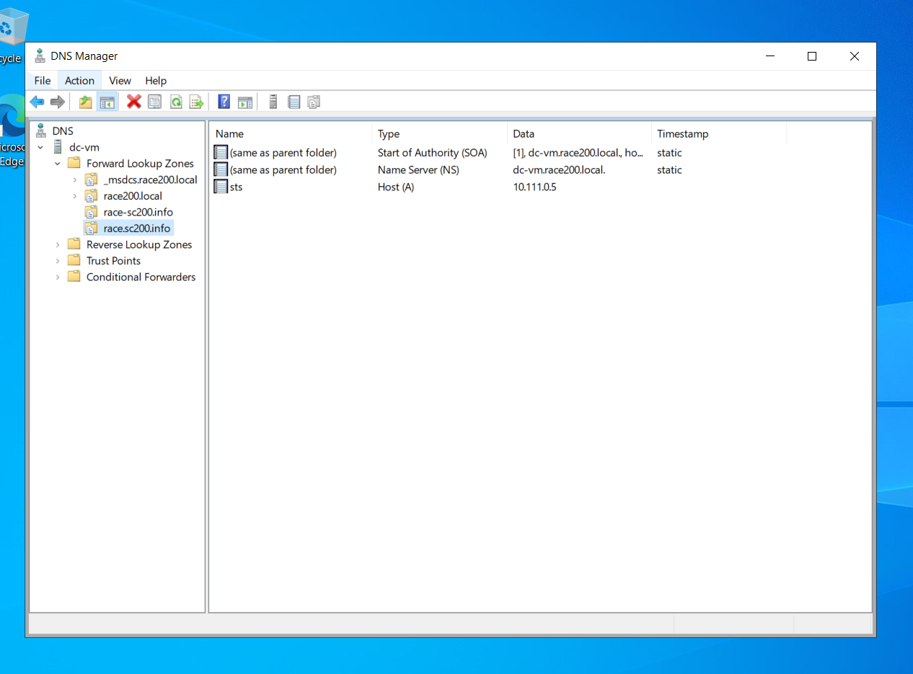

Below is the screenshot where able to ping from my laptop

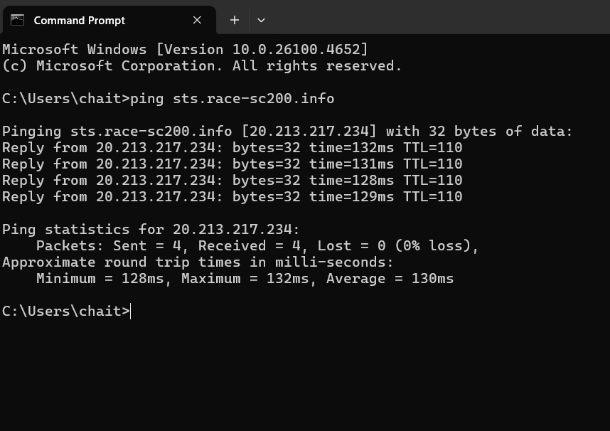

Below is the screenshot where able to ping from dc-vm

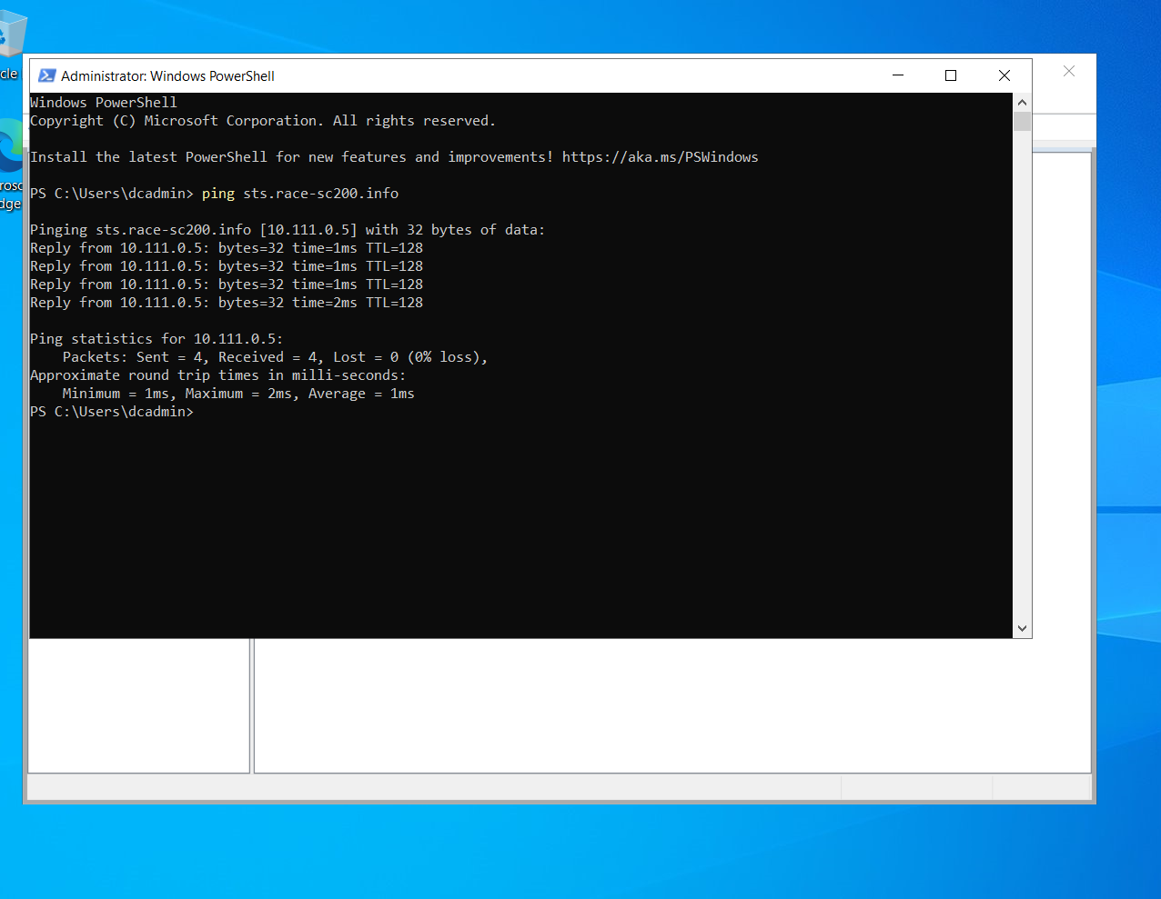

Below is the screenshot where able to ping from mem-vm

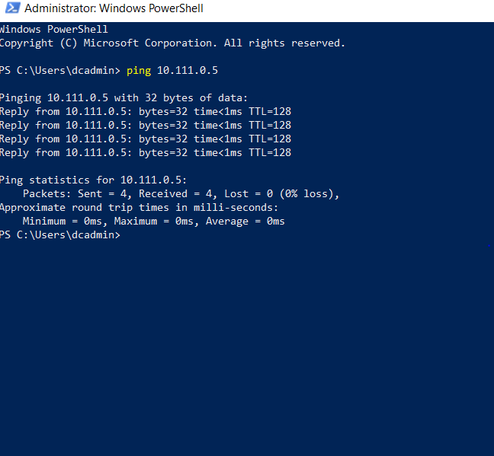

This configuration is called as Split DNS configuration.

Split DNS, also known as split-horizon DNS or split-brain DNS, is a DNS configuration strategy where the same domain name resolves to different IP addresses depending on whether the DNS query originates from within the internal network or from the external (public) internet.

1. **Synchronization – (Cloud Sync)**

**DirSync and Cloud Sync are tools used to synchronize on-premises Active Directory (AD) with Azure Active Directory (Azure AD). They allow hybrid identity scenarios, such as enabling single sign-on (SSO) and managing users from your on-prem AD while using Microsoft cloud services like Microsoft 365**

NOTE: To do DirSync or CloudSync some component should be installed

In mem-vm Goto-> local server –> Internet explorer enhanced security config – off

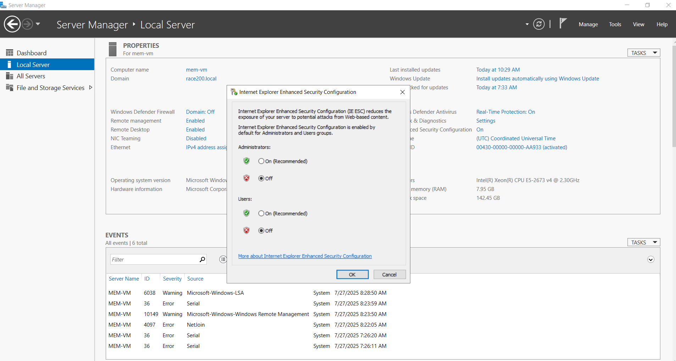

Now in mem-vm –> use edge browser

Now download Entra connect from azure Entra id – Entra connect – connect sync

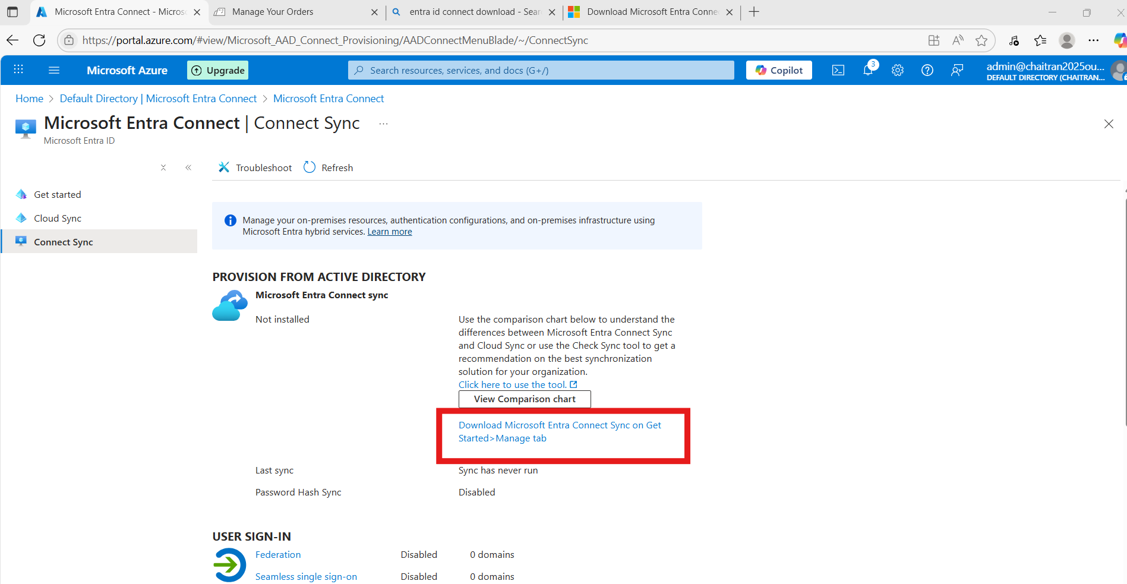

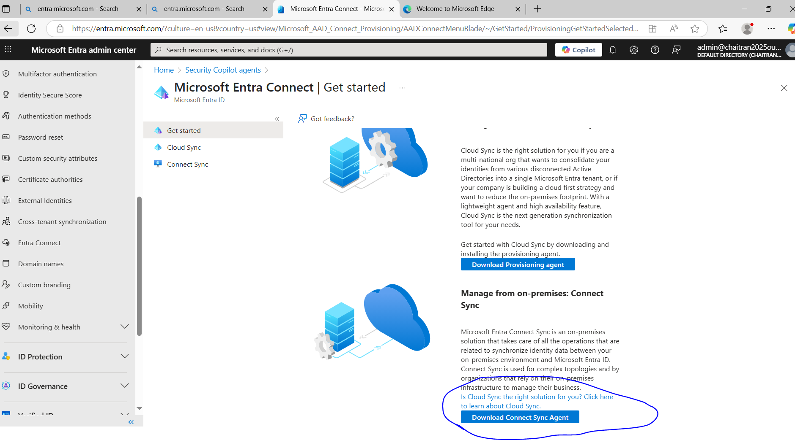

AzureAdConnect is the product downloaded

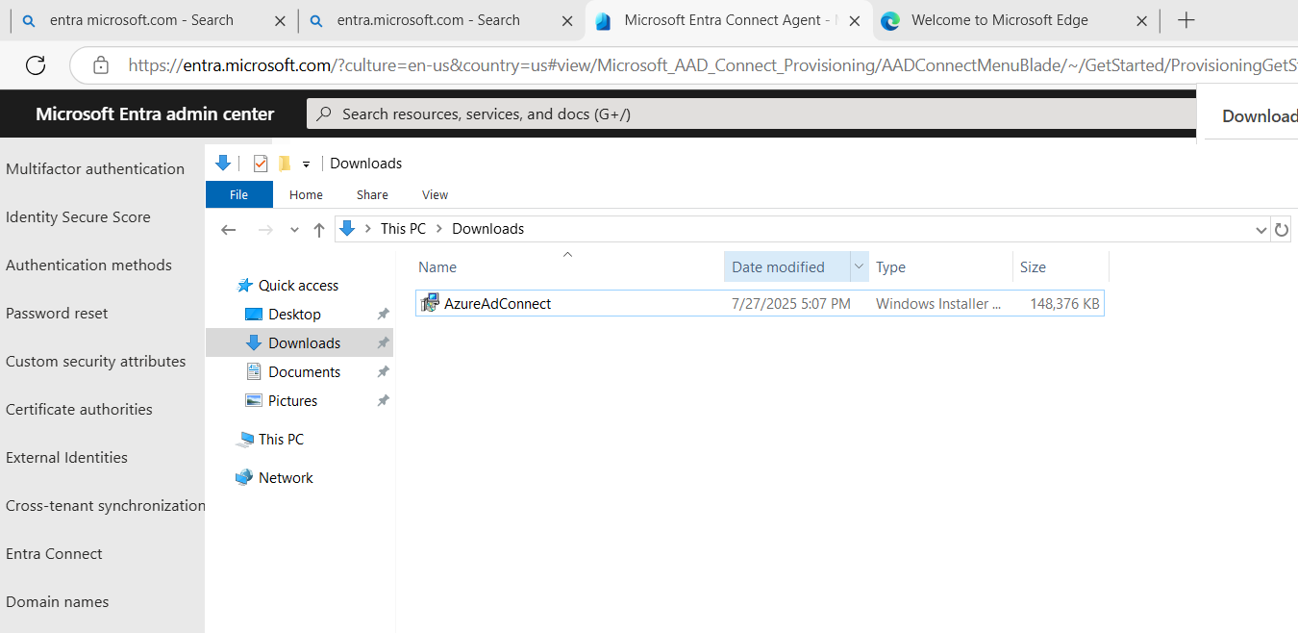

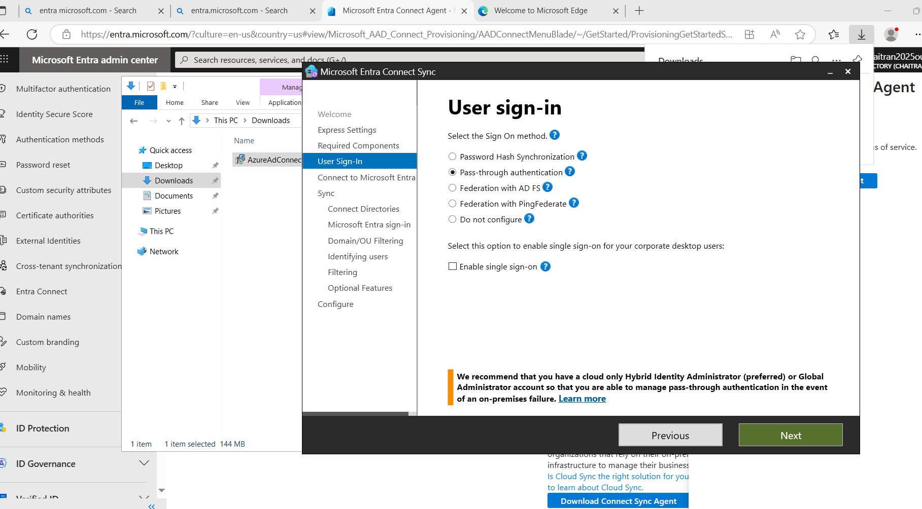

**Download Cloud Sync Agent**

In mem-vm, login azure and goto Entra id and select cloud Sync

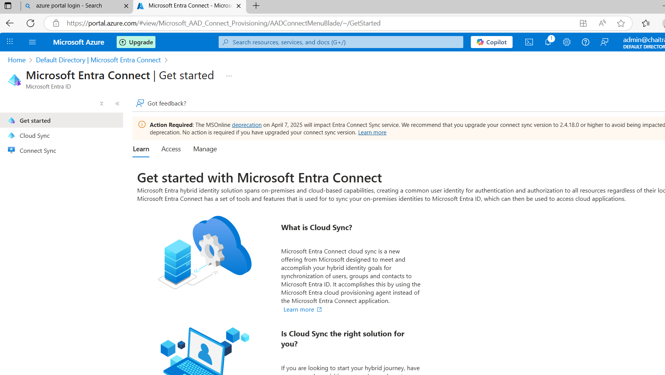

Download the provisioning agent

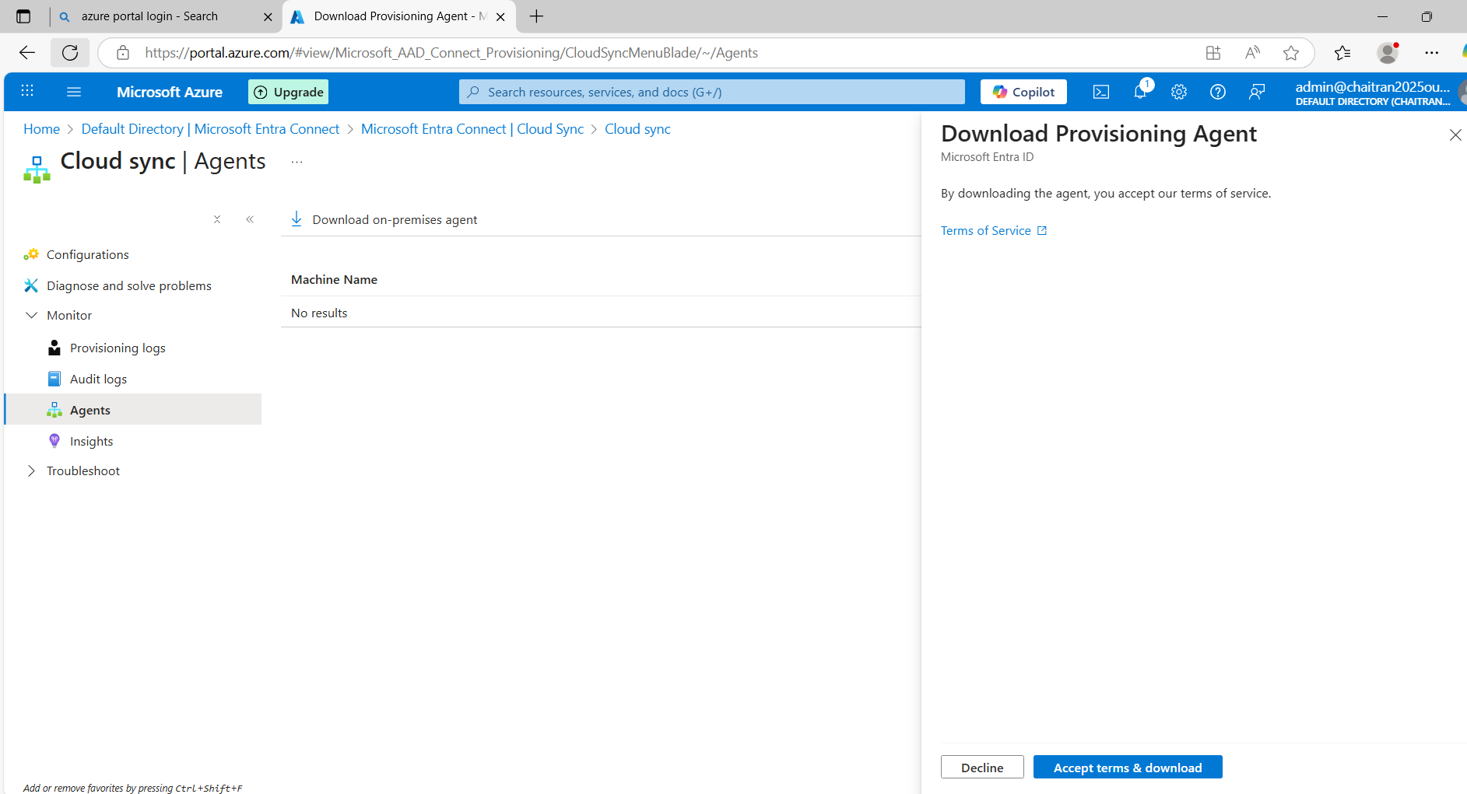

Install the Entra Provisioning Agent

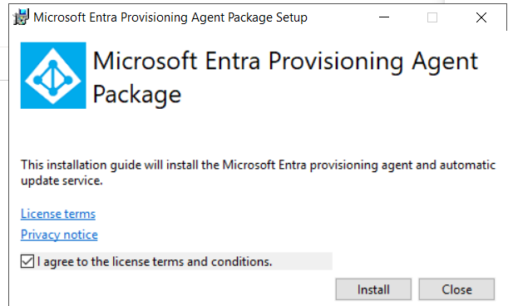

Configure Provisioning Agent

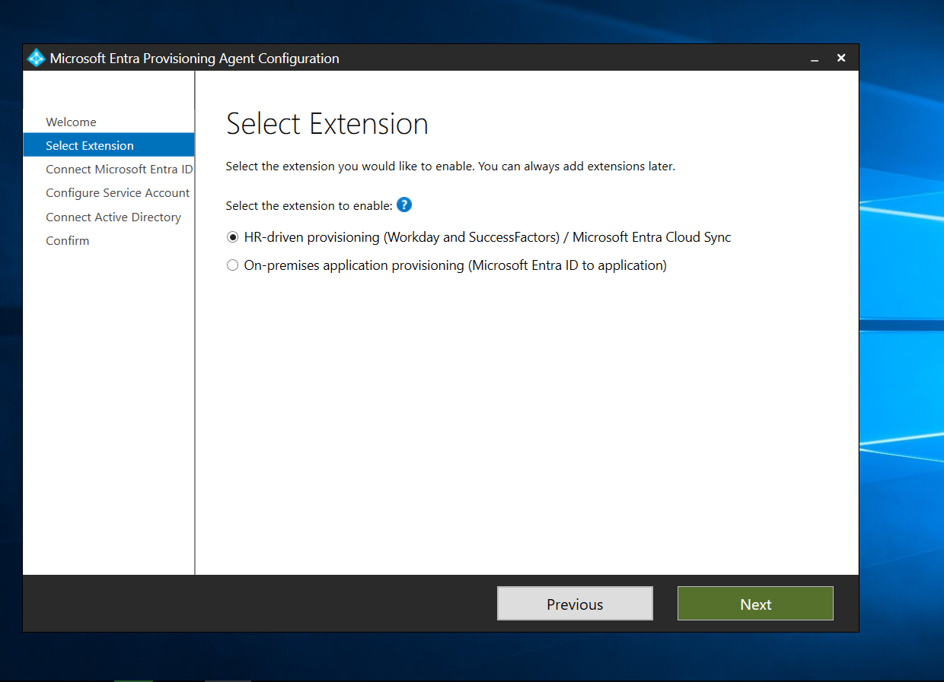

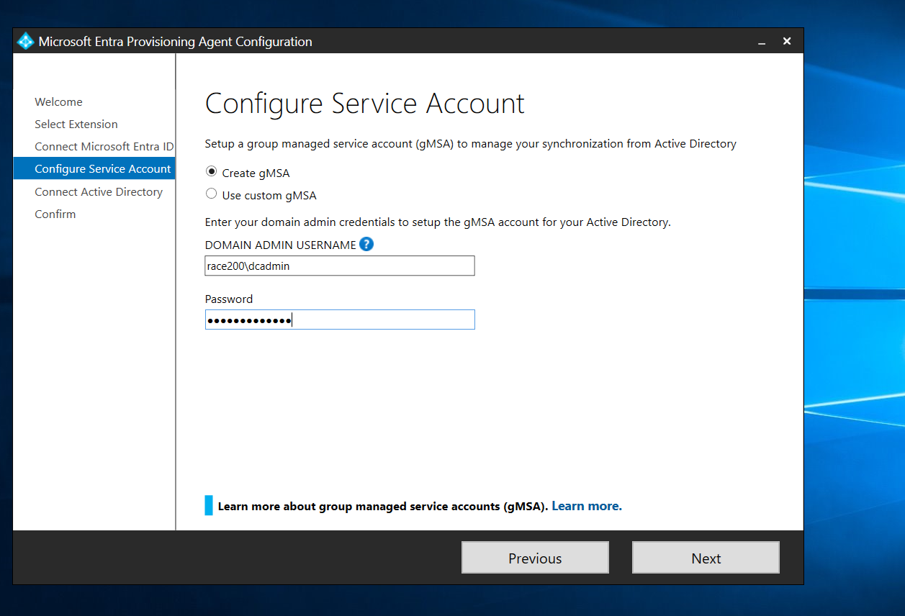

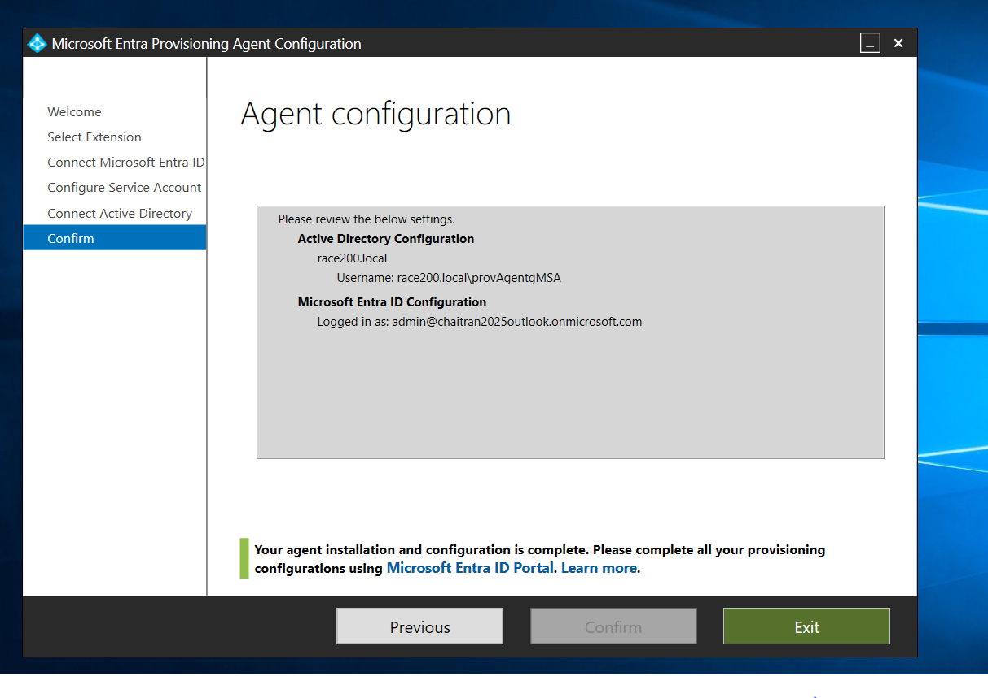

**In Azure Cloud Sync Configuration**

Goto Azure cloud - Microsoft Entra – Cloud Sync, new config and disable password hash and create cloud sync configuration.

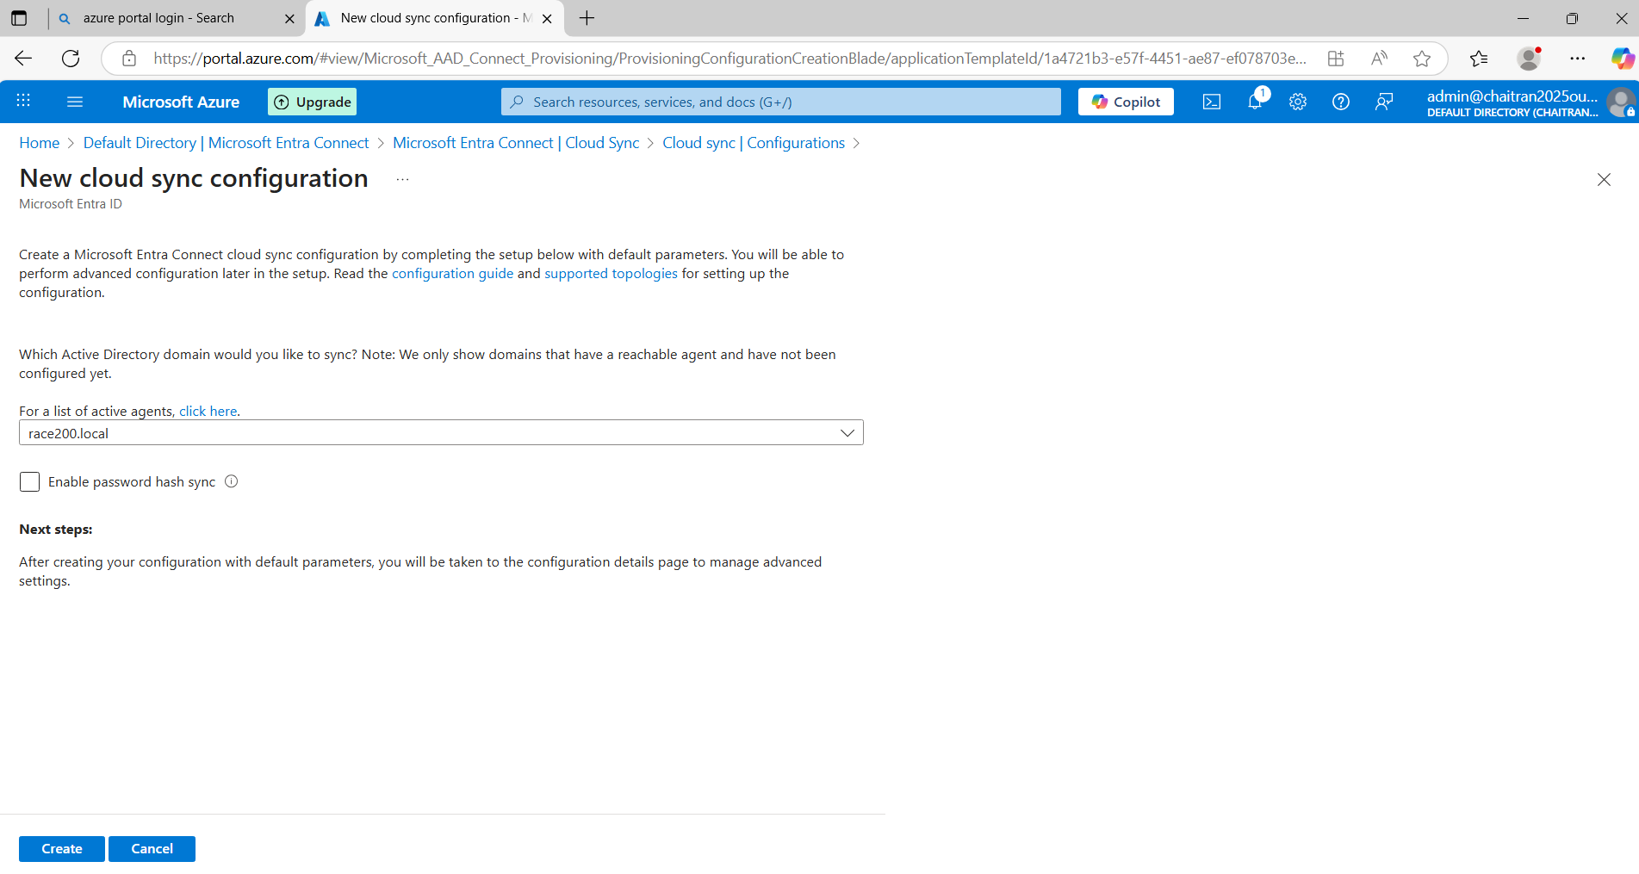

To Check if it is Synchronized

Goto Azure cloud - Microsoft Entra – Cloud Sync - Monitor – Provisioning logs and see the Action is Update

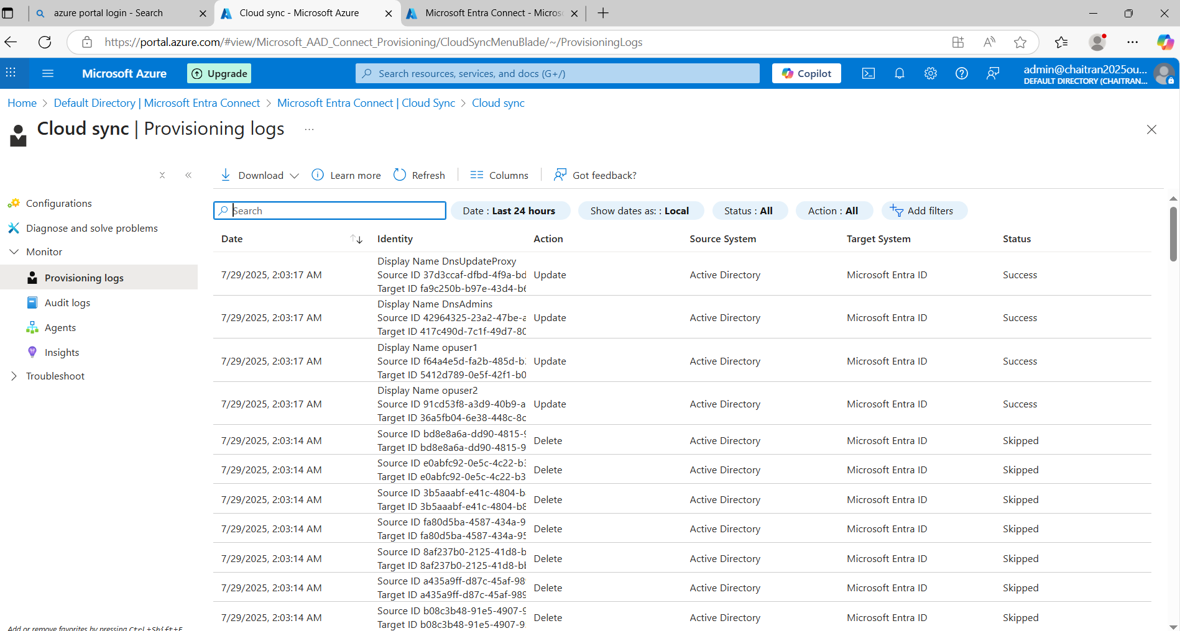

Now click on that update to see the log details

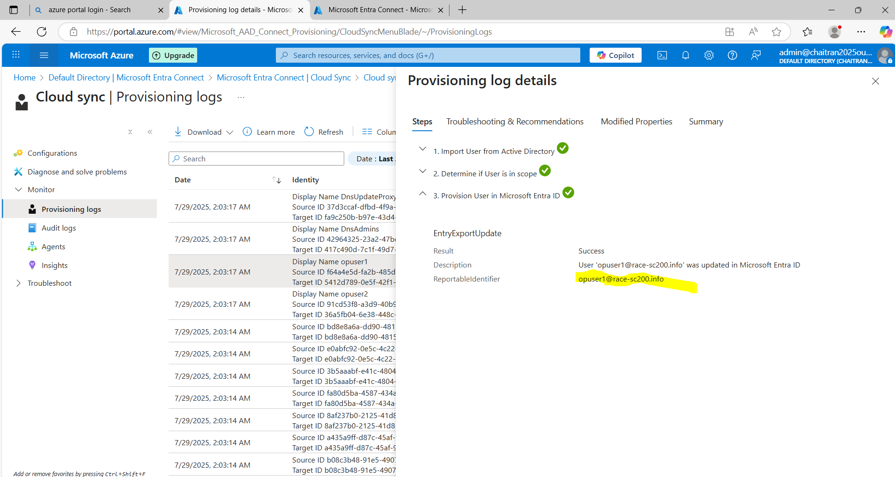

Review and Enable Configure

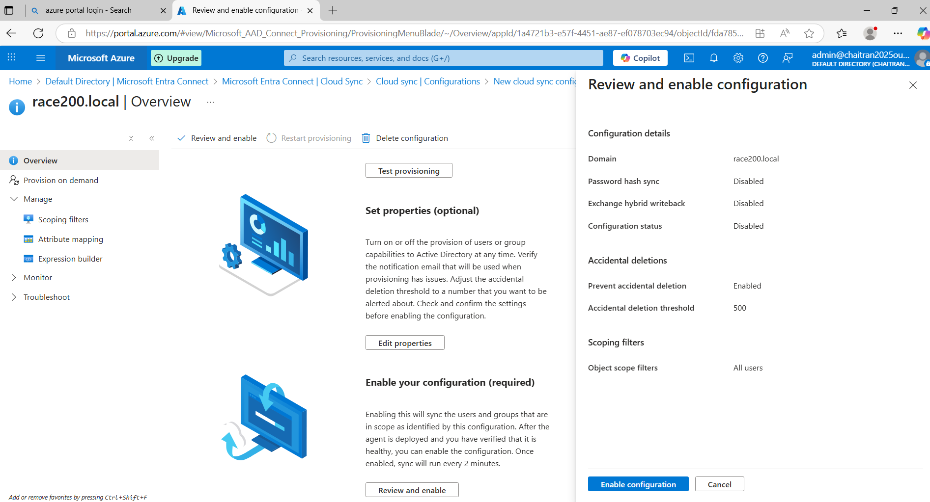

To check if it is Cloud Sync

Goto users and check

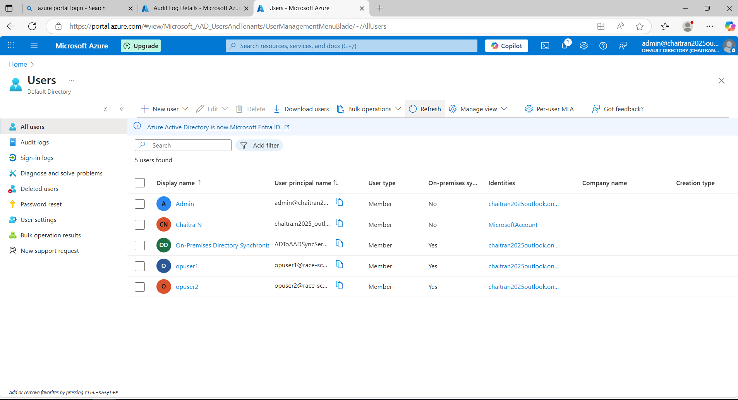

Here, opuser1 and opuser2 are shown which is synchronized to cloud.

1. **Pass-Through Authentication (PTA)**

In mem-vm Goto-> local server –> Internet explorer enhanced security config – off



Now in mem-vm –> use edge browser

Now download Entra connect from azure Entra id – Entra connect – connect sync



Download the Connect Sync Agent



AzureAdConnect is the product downloaded



Install Required Components

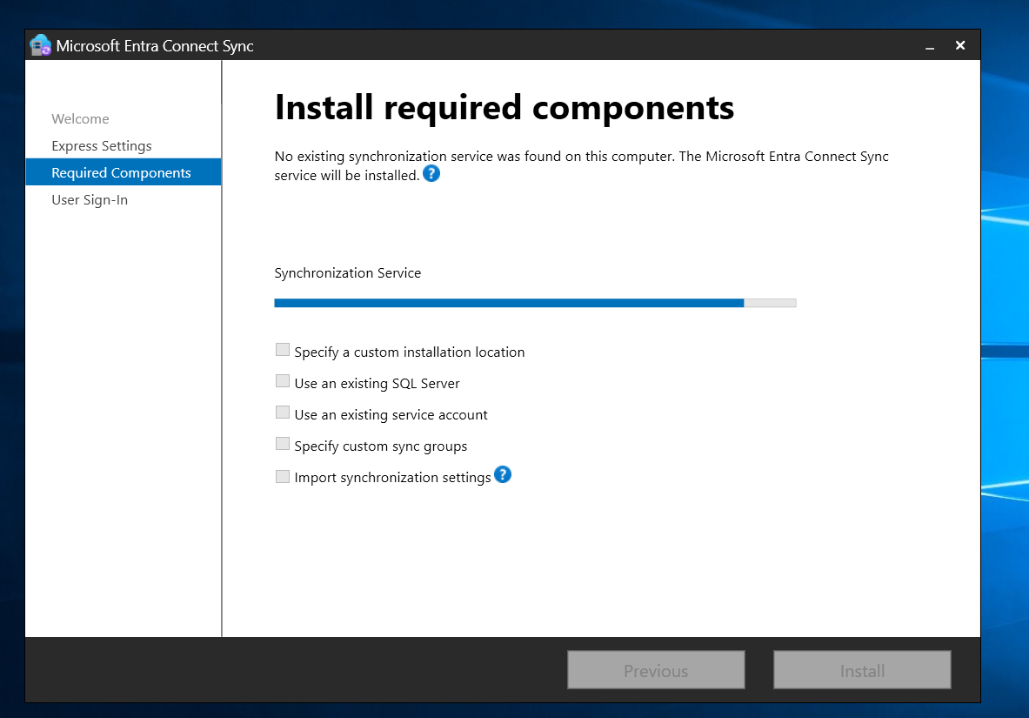

Now click on AzureAdConnect, select Pass-through authentication

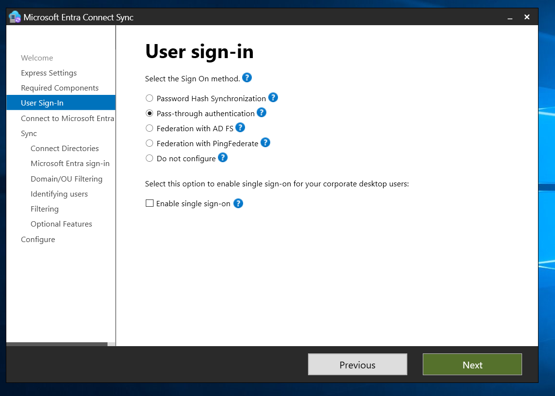

Provide the Azure logged in username

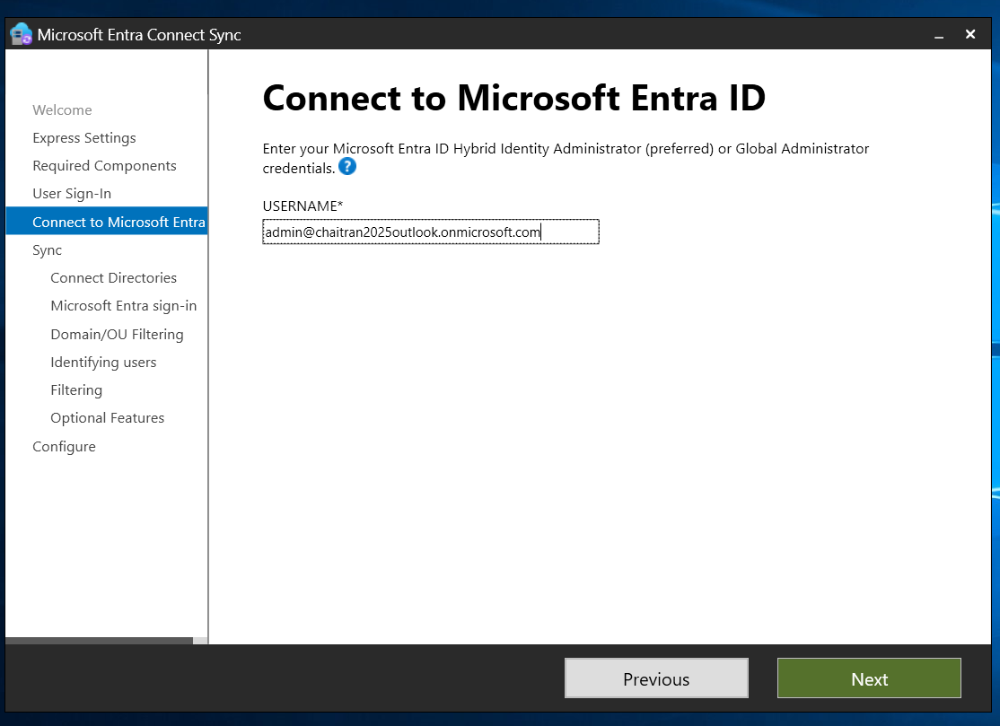

Create new AD account

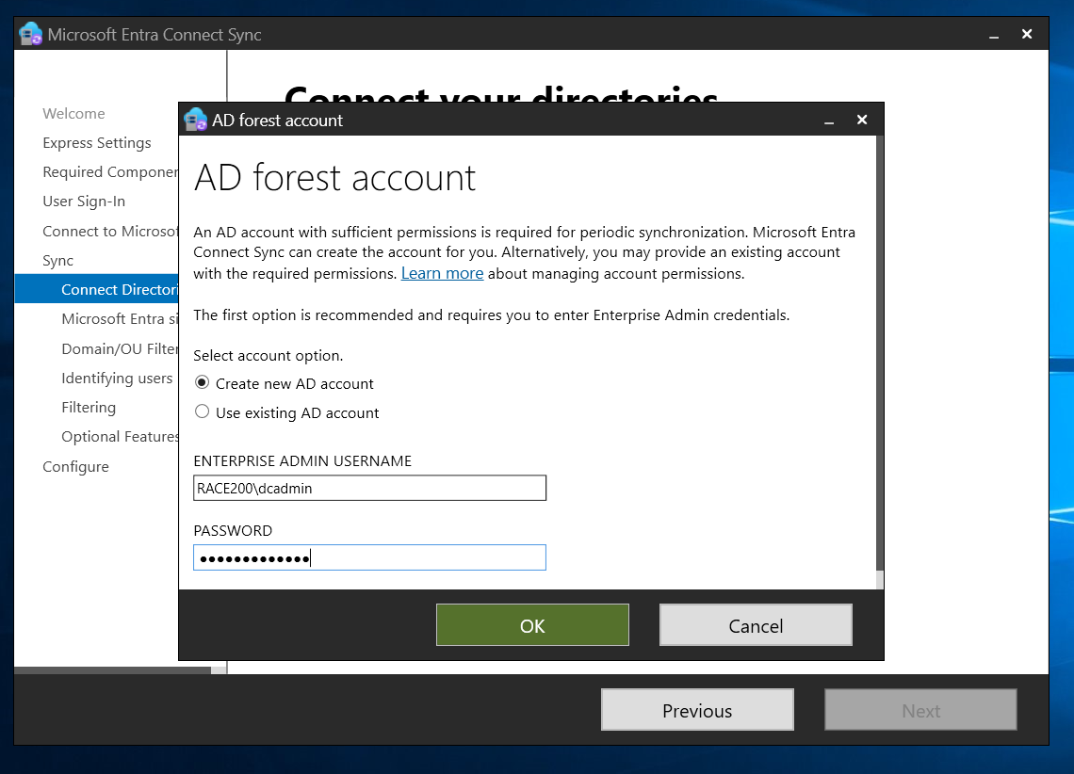

Add Directory

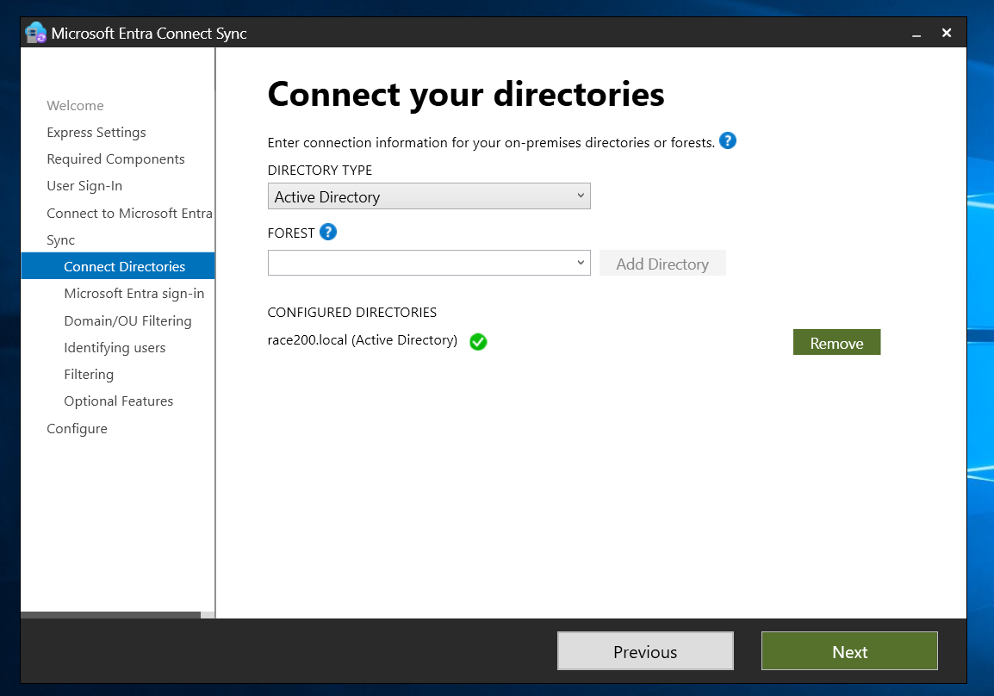

Select domains and OU which need to be sync

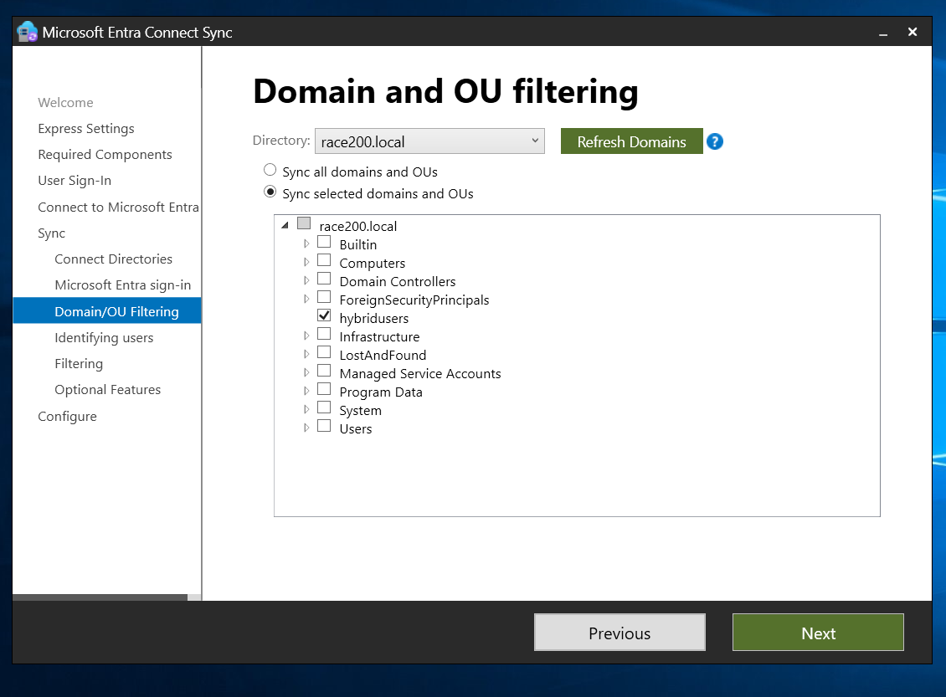

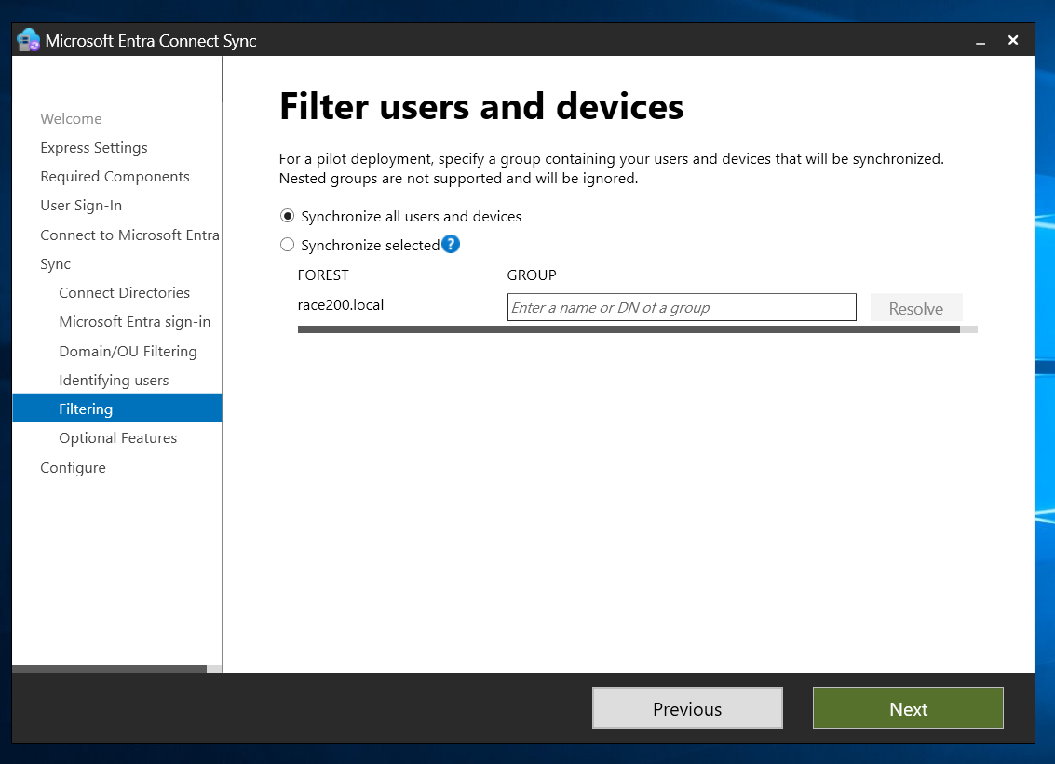

Click on Install

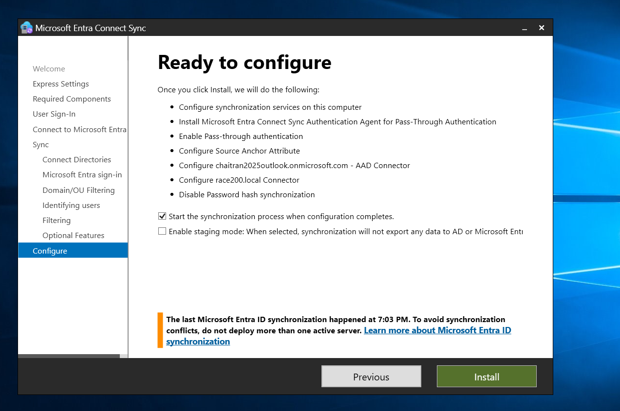

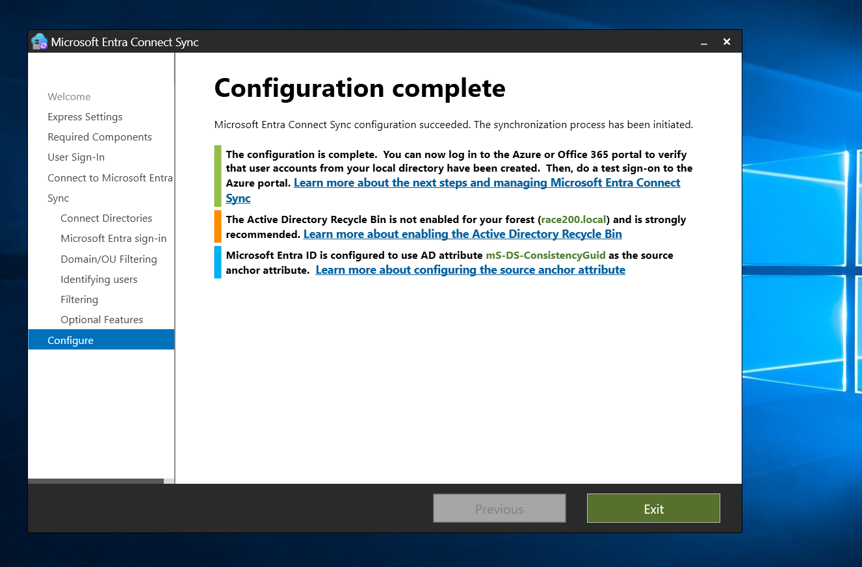

After installation, check if the users are synchronized in cloud

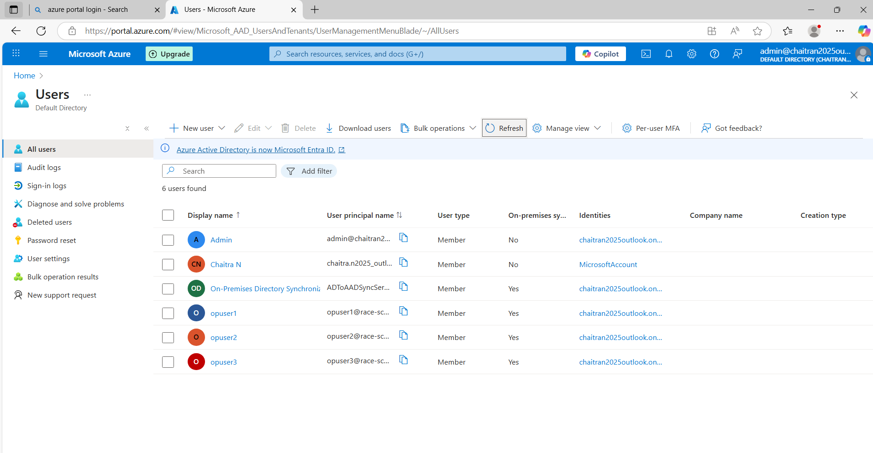

Now login 0365 by using one of the users, here I have logged in [**opuser1@race-sc200.info**](mailto:opuser1@race-sc200.info)

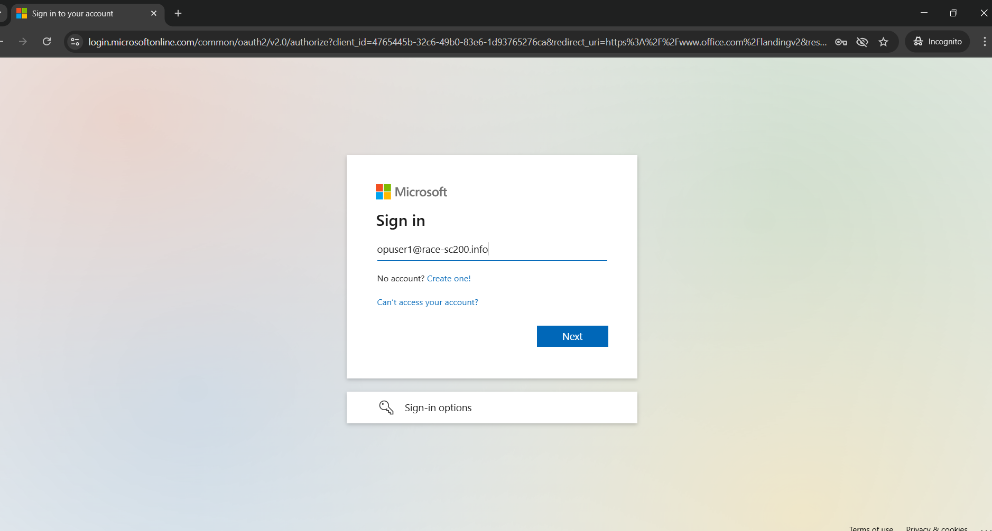

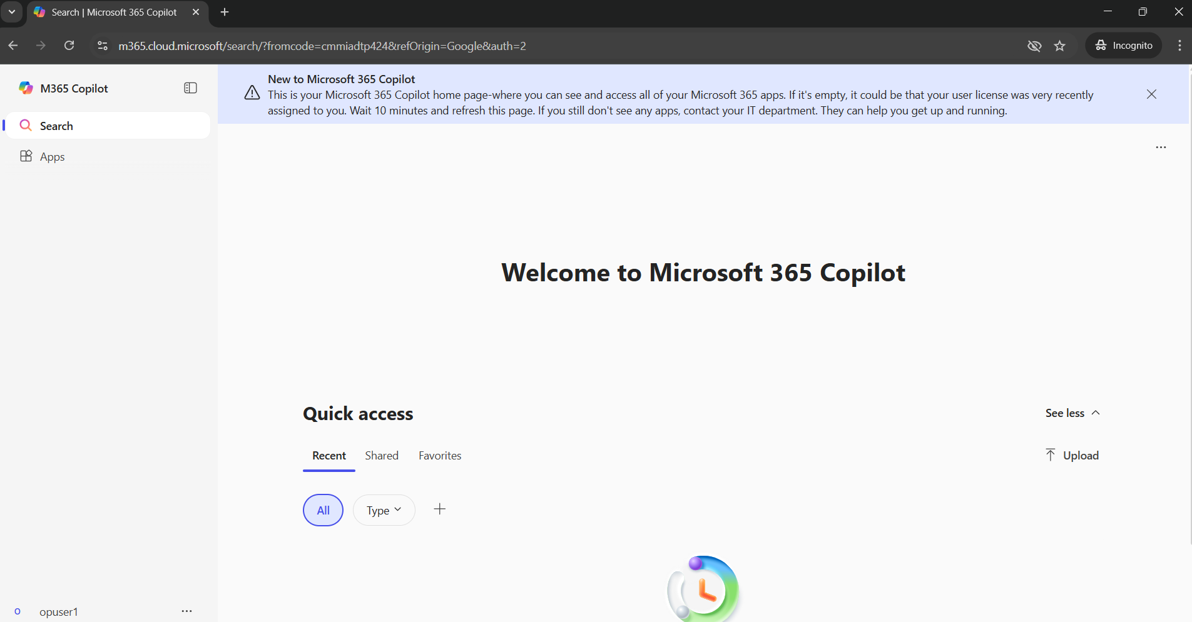

**Below is the screenshot where opuser1 is successfully logged in**

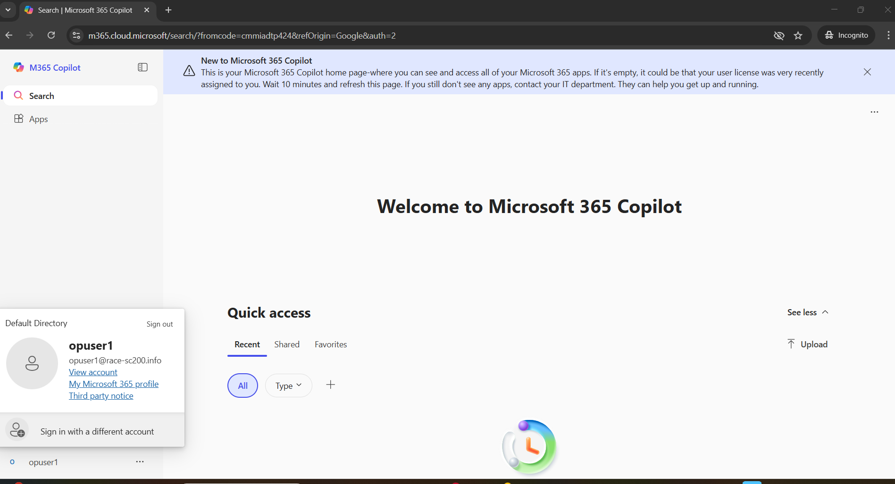

**To Verify Authentication Method in Azure**

Goto Entra ID 🡪 Monitor 🡪 Sign-in events 🡪 Click on opuser1

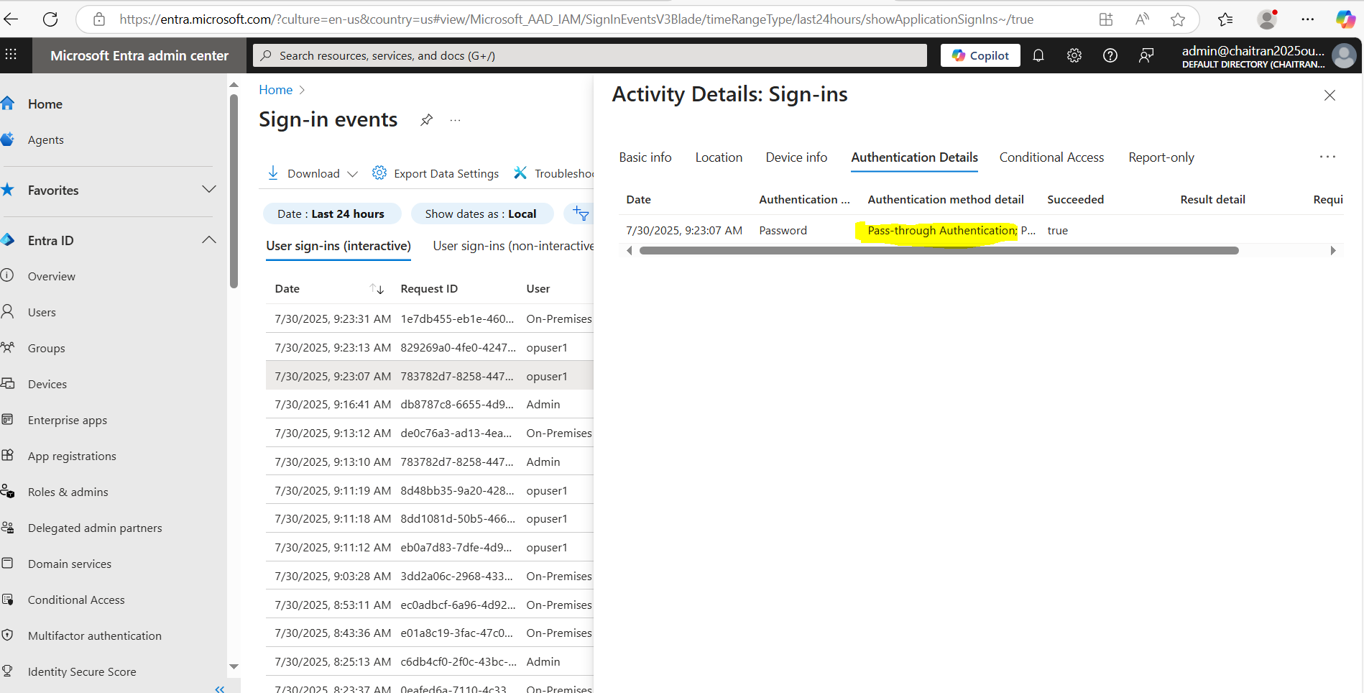

**Hence, the verification confirms that the user's credentials are valid and that the sign-in process is correctly routed through the PTA system.**

1. **GENERATE CERTIFICATION**

In dc-vm, select server roles

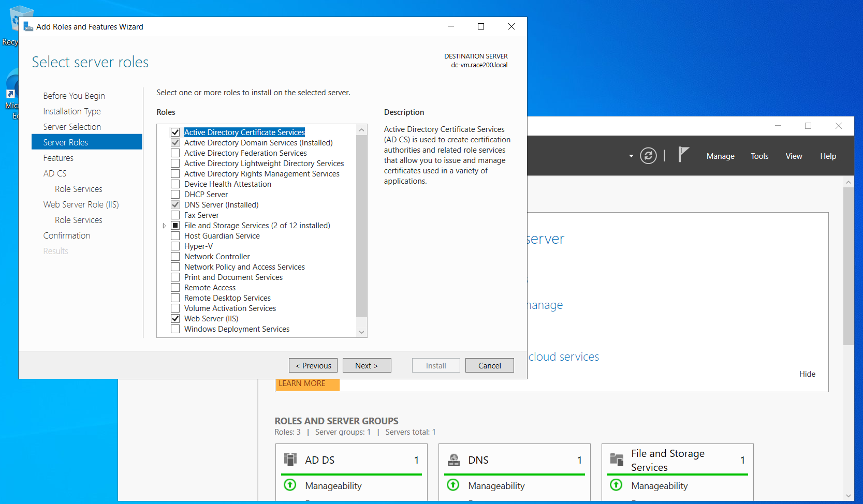

Check the Certificate Authority and Certificate Authority Web Enrolment under Role Services

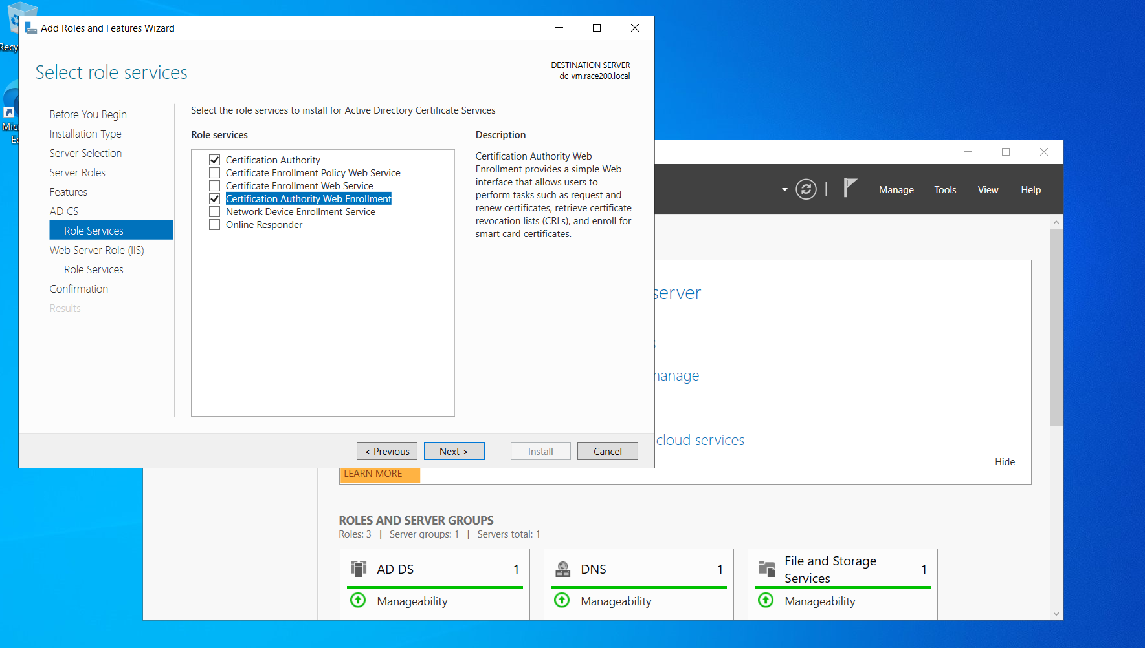

Now in mem-vm install IIS

Goto Add roles and Features wizard, select Web Server (IIS)

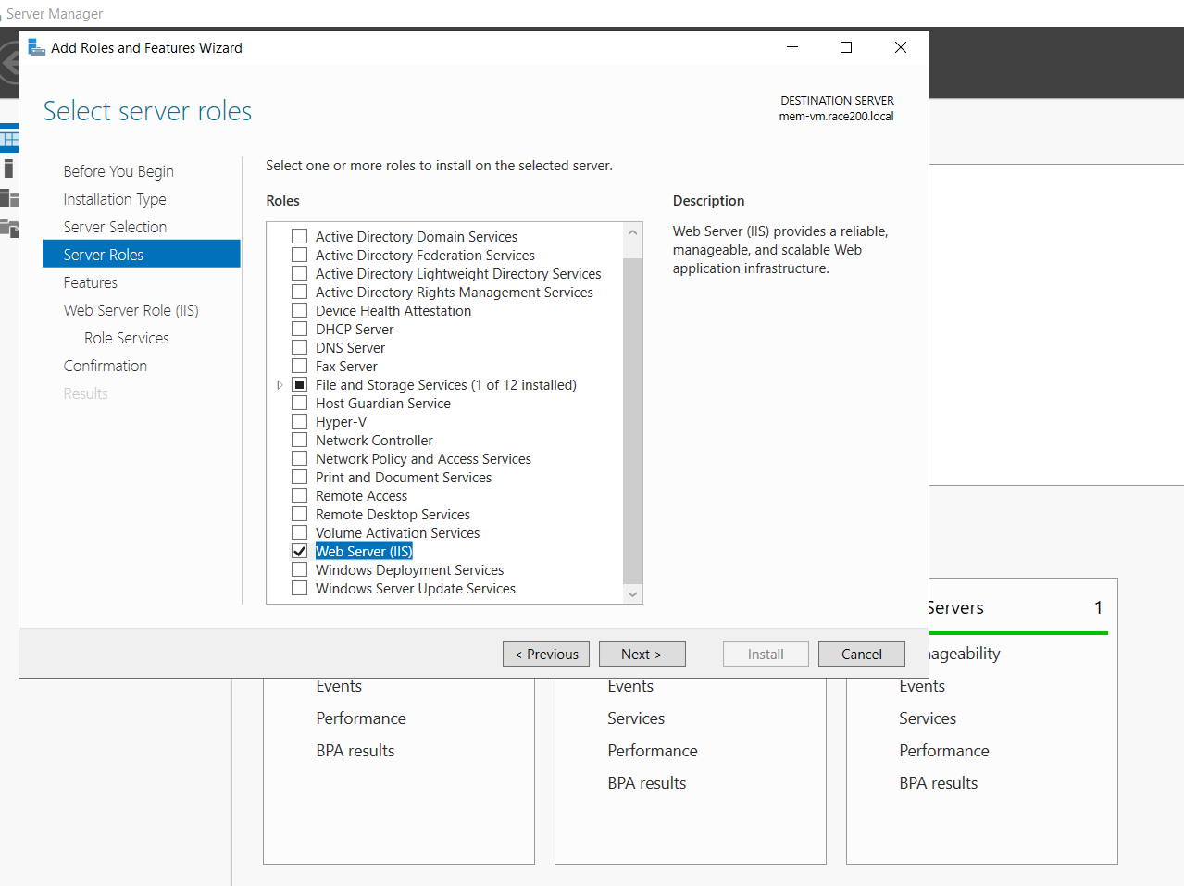

Enable all security and application development

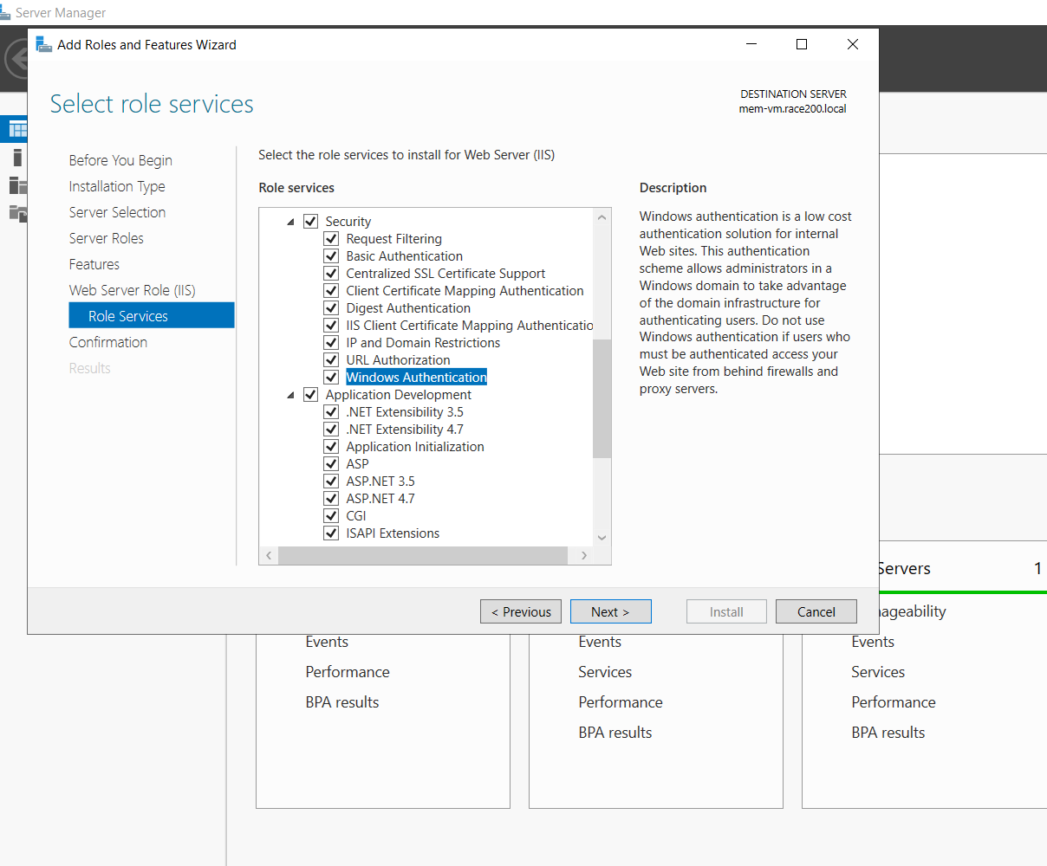

Now in dc-vm, it is installed.

Now should configure,

Configuring both certification authority and web enrolment.

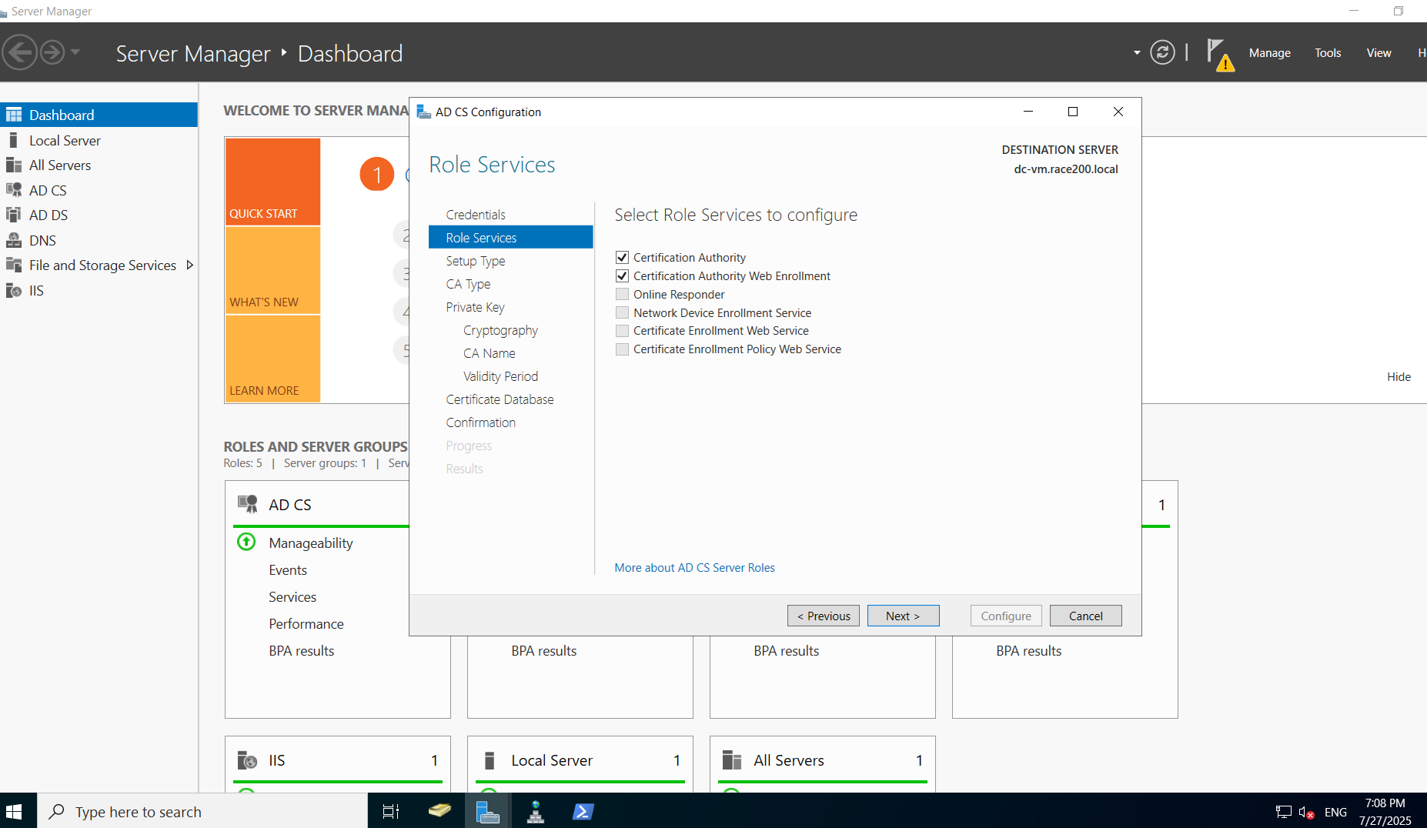

It is configured and Certificate is generated.

Now will be able to open from domain name **dc-vm.race200.local**

Below is the screenshot.

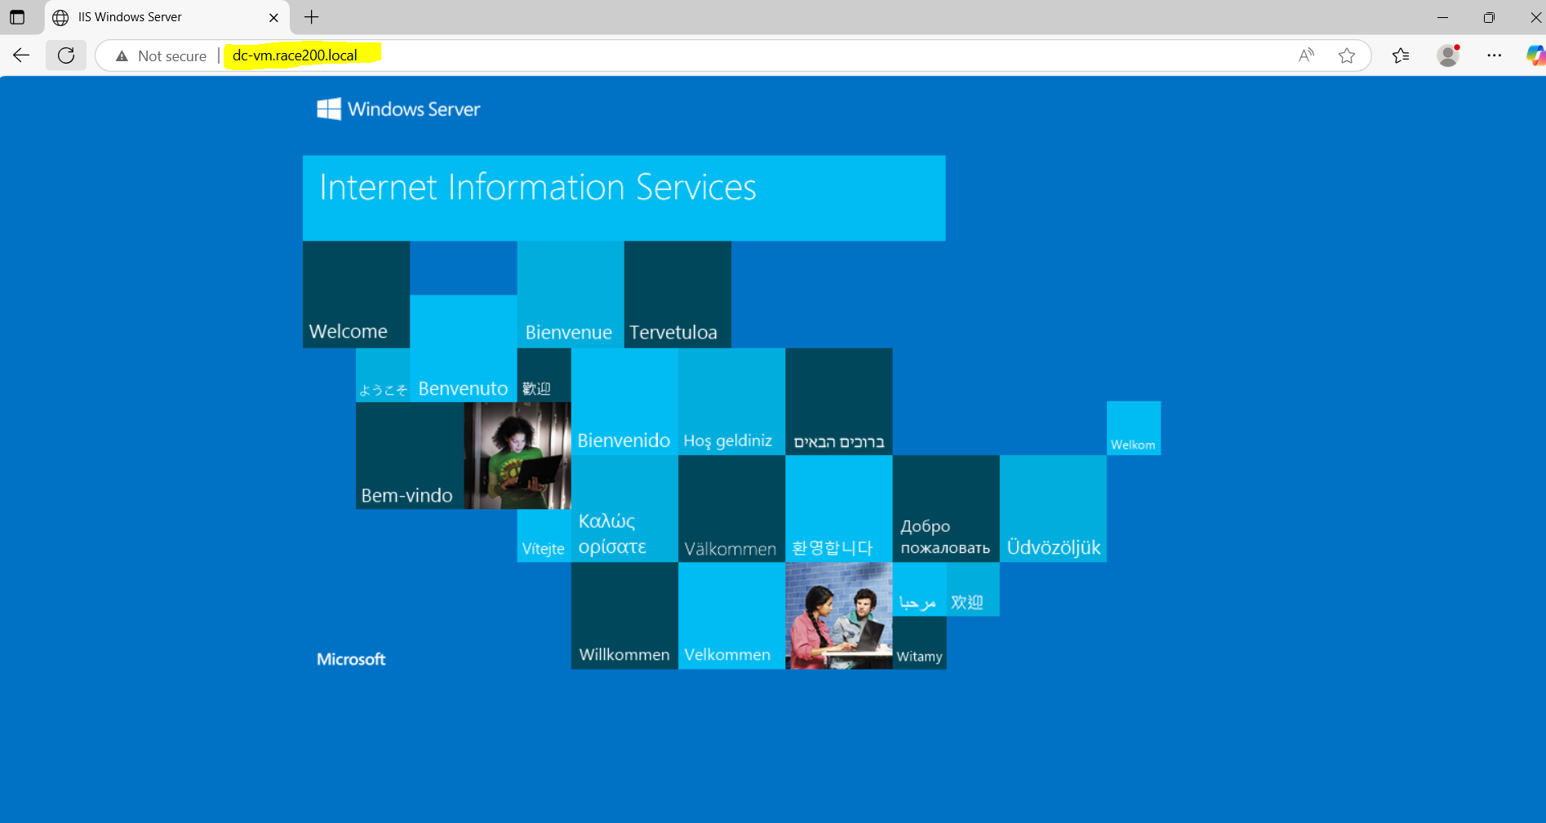

Browse **dc-vm.race200.local/certsrv**

"**certsrv**" refers to the **Certificate Services web enrollment** feature in **Microsoft Windows Server**. It provides a web-based interface to a Certification Authority (CA), allowing users to:

* Request certificates
* Retrieve issued certificates
* Download the CA certificate chain
* Request certificate revocation

https://<servername>/certsrv or

http://<servername>/certsrv)

**Here, browse dc-vm.race200.local/certsrv**

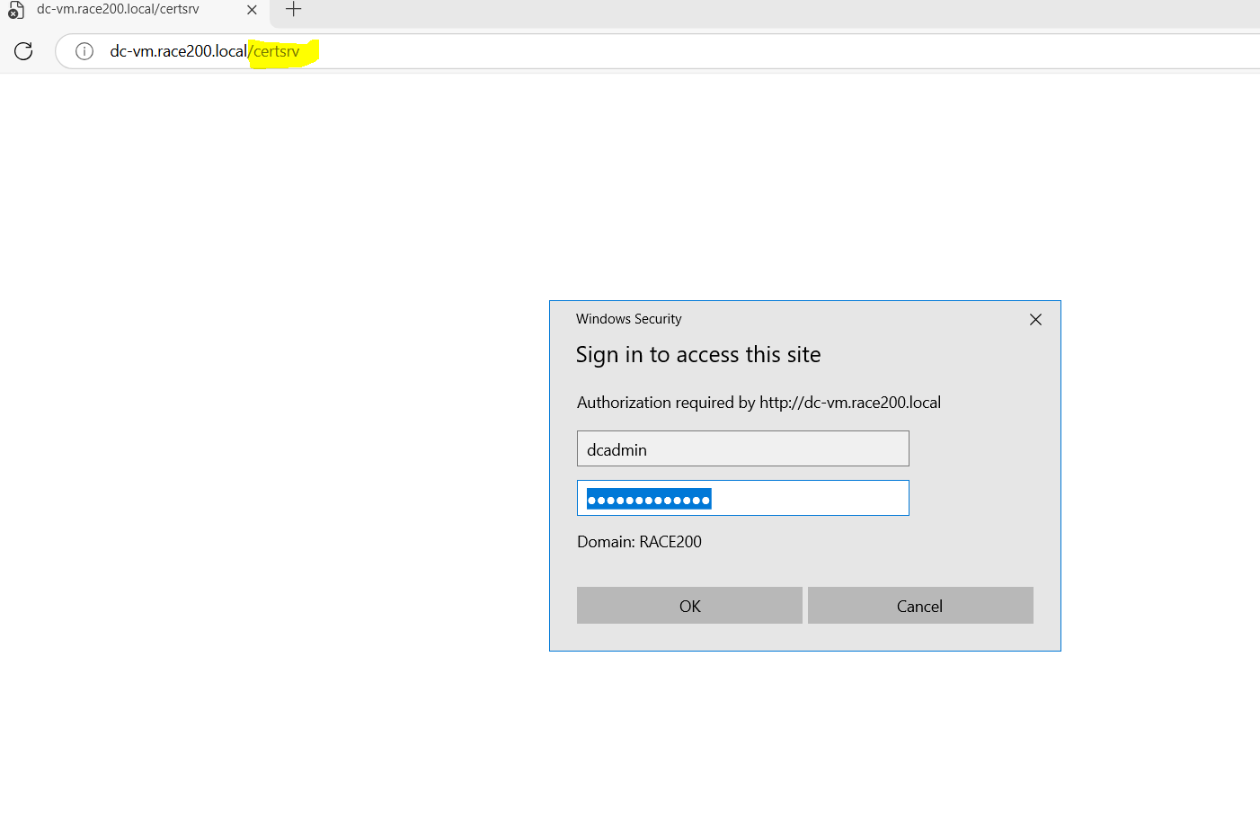

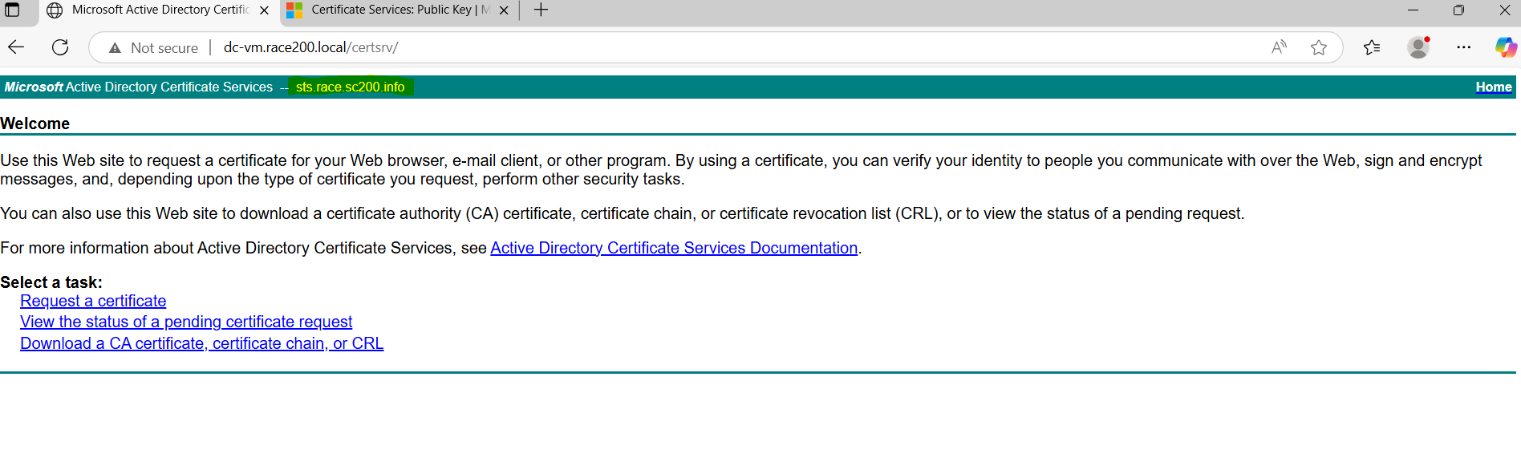

Hence generated certificate with the common name as **sts.race.sc200.info**

**Verify Certificate in mem-vm**

Goto Administrative tools in mem-vm, select Internet Information Services (IIS)

click on MEM-VM 🡪 Select Server Certificates

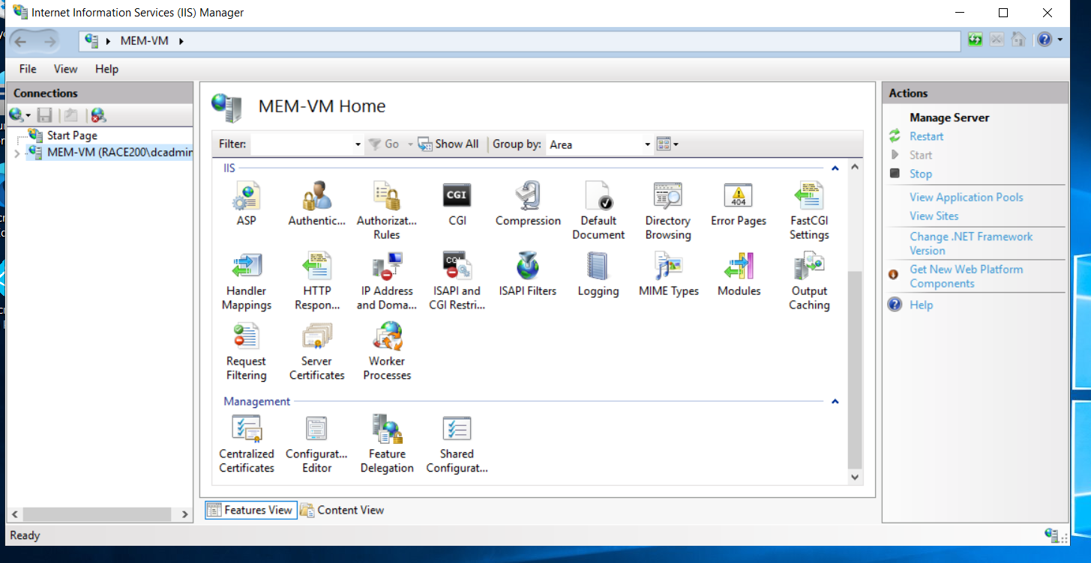

Create Domain Certificate

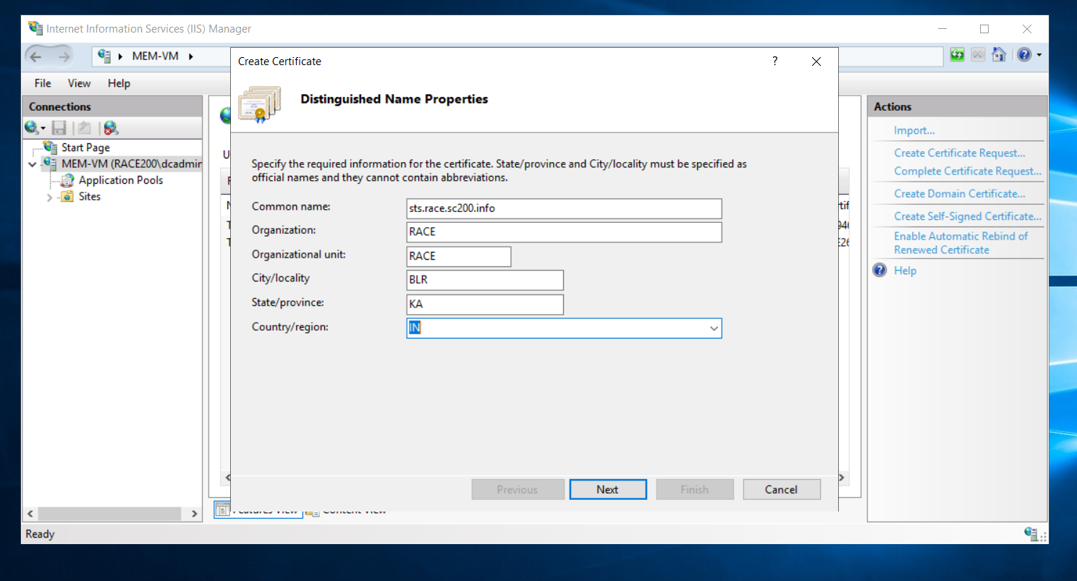

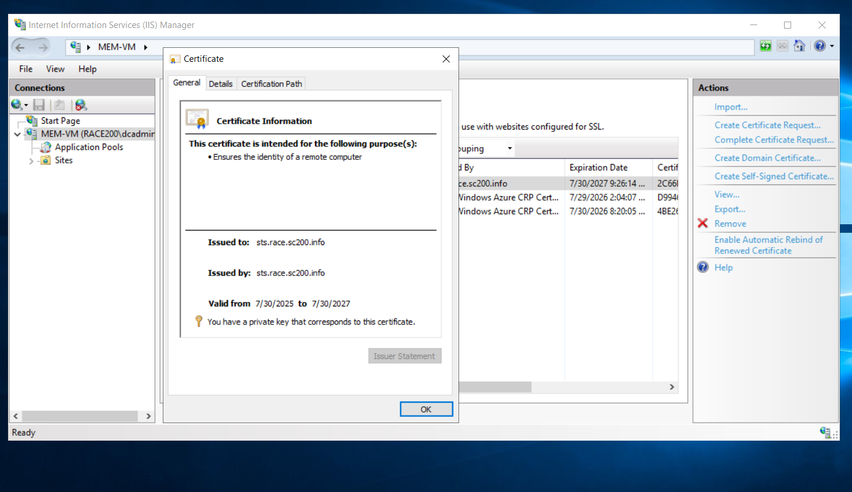

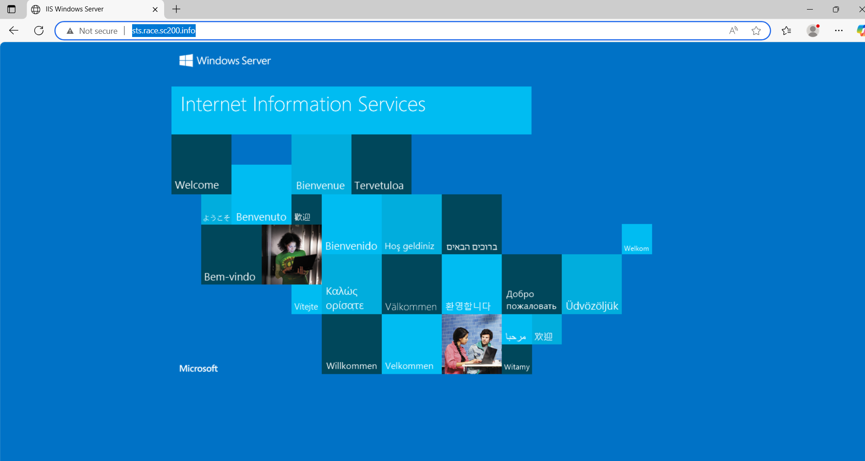

Hence verified certificate with the common name as **sts.race.sc200.info**

**Comparison between PTA and ADFS, explaining when each should be used**

**PTA (Pass-through Authentication)**

* How it works: Authenticates users directly against on-premises Active Directory via a lightweight agent without storing passwords in the cloud.
* Infrastructure: Requires minimal infrastructure (just an agent on-premises).
* Security: Password never leaves the organization; supports modern security features like Azure AD Conditional Access.
* Maintenance: Easier to deploy and maintain compared to ADFS.

Use PTA when:

* You want a simpler, cloud-managed solution.
* You don't need complex claims-based access or integration with non-Microsoft services.
* You want to reduce infrastructure and management overhead.

**ADFS (Active Directory Federation Services)**

* How it works: Federates authentication requests between on-prem AD and Azure AD using tokens.
* Infrastructure: Requires multiple on-prem servers (ADFS, WAP, load balancers).
* Security: Full control over the authentication process; supports advanced claims and customization.
* Maintenance: Higher complexity and operational overhead.

Use ADFS when:

* You need advanced authentication scenarios (e.g., smart cards, third-party MFA, custom claims rules).
* You're integrating with non-Microsoft identity providers or legacy systems.
* You require full on-prem control over authentication flows.

**Summary:**

PTA is for simplicity and cloud-first strategies, especially when integrating with Microsoft cloud services. It's generally recommended for new hybrid deployments unless specific, complex requirements dictate otherwise.

ADFS is for complex, highly customized, or legacy integration scenarios where on-premises control and broader protocol support are paramount. However, Microsoft's push is towards cloud authentication, so ADFS is increasingly seen as a solution for specific edge cases rather than the default.

| Feature | PTA | ADFS |
| --- | --- | --- |
| Complexity | Low | High |
| Infrastructure | Minimal (agent only) | Requires full ADFS stack |
| Use Cases | Simple cloud integration | Advanced or legacy scenarios |
| Security Control | Moderate (cloud-managed) | Full on-prem control |